**A major project report on**

**DESIGN OF MULTI LAYER MICROSTRIP PATCH ANTENNA FOR WLAN APPLICATIONS**

**A Major Project report Submitted in partial fulfillment of the Academic requirements for the award of the degree of**

**Bachelor of Technology in**

**Electronics & Communication Engineering**

Submitted by

**MONAGARI RAKESH AITHA RAGHU VAMSHI CHILUKA BHAVANA**

**(18H51A0448) (18H51A0462) (18H51A0438)**

##### Under the esteemed Guidance of

**Mr. V. Santhosh Kumar**

##### Associate Professor, Dept. of ECE



**DEPARTMENT OF ELECTRONICS & COMMUNICATION ENGINEERING CMR COLLEGE OF ENGINEERING & TECHNOLOGY**

**(NAAC Accredited with ‘A+’ Grade & NBA Accredited) (Approved by AICTE, Permanently Affiliated to JNTU Hyderabad)**

**KANDLAKOYA, MEDCHAL ROAD, HYDERABAD-501401**

**2020-21**

**CMR COLLEGE OF ENGINEERING & TECHNOLOGY**

**(NAAC Accredited with ‘A+’ Grade & NBA Accredited) (Approved by AICTE, Permanently Affiliated to JNTU Hyderabad)** KANDLAKOYA, MEDCHAL ROAD, HYDERABAD-501401

**DEPARTMENT OF ELECTRONICS & COMMUNICATION ENGINEERING**



**CERTIFICATE**

This is to certify that the project report entitled **“DESIGN OF MULTI LAYER MICROSTRIP PATCH ANTENNA FOR WLAN APPLICATIONS”** is a bonafide work done by **MONAGARI RAKESH (18H51A0448), AITHA RAGHU VAMSHI (18H51A0462), CHILUKA BHAVANA(18H51A0438)** ofIV year B. Tech ECE, in partial fulfillment of the requirements for the award of the degree of Bachelor of Technology in Electronics & Communication Engineering, submitted to the Department of Electronics and Communication Engineering, CMR College of Engineering & Technology, Hyderabad during the Academic Year 2020-21.

**Mr . V. Santhosh Kumar**

**Associate Professor, Department of ECE (**Project Guide**)**

**Prof. E.N.V. PURNA CHANDRA RAO**

**HOD, Department of ECE**

**ACKNOWLEDGEMENT**

We are highly indebted and grateful to our guide, **Mr. V. Santhosh Kumar,** Associate Professor, Department of ECE, CMRCET for his excellent guidance and constant encouragement throughout for the successful completion of the Project.

We are obliged and grateful to thank, **Prof. E. N. V. PURNA CHANDRA RAO,**

HOD Department of ECE, CMRCET**,** for his cooperation in all respects.

We are obliged and grateful to thank, **Dr. B. LOKESHWAR RAO**, Dean (Academics), CMRCET, for his cooperation in all aspects.

We would like to thank **Major Dr. VA NARAYANA**, Principal, CMRCET, for his support in the course of this project work.

We would like to thank **Sri Ch. GOPAL REDDY** garu, Secretary and Correspondent of CMRCET, for his cooperation in all respects during the course.

It gives immense pleasure in expressing our deep sense of gratitude to Project in-charge, **Mr. P. RAVEENDRA BABU**, Associate Professor, Department of ECE, CMRCET for his valuable suggestions in each and every review during the course of my project.

Finally, we would like to thank all teaching & non- teaching staff members of the department for their cooperation and support throughout the duration of our course.

Ultimately, we own all our success to our beloved parents, whose vision, love and inspiration has made us to reach out for these glories.

**SIGNATURE**

MONAGARI RAKESH AITHA RAGHU VAMSHI CHILUKA BHAVANA

(18H51A0448) (18H51A0462) (18H51A0438)

**DECLARATION**

We hereby declare that results embodied in this Report of Project on **“DESIGN OF MULTI LAYER MICROSTRIP PATCH ANTENNA FOR WLAN APPLICATIONS”** are from work carried out by using partial fulfillment of the requirements for the award of B. Tech degree. We have not submitted this report to any other university/institute for the award of any other degree.

**SIGNATURE**

MONAGARI RAKESH AITHA RAGHU VAMSHI CHILUKA BHAVANA

**DATE:**

(18H51A0448) (18H51A0462) (18H51A0438)

**ABSTRACT**

Modern telecommunication systems require antennas with multiband characteristics that support multiple wireless applications. With the advances in the field of communication and the current state of affairs in the development of antennas the need of compact multiband, multifunctional and cost- effective antenna is increased. The study of reconfigurable antennas has made great progress in recent years. They are lighter in weight, smaller in dimension and lower in price.

In this project, low cost printed microstrip line fed pentagon-shaped ultra-wideband antenna offering dual band notched characteristics response is proposed and investigated. By introducing modified rectangular-shaped slot in the pentagonal patch and hexagonal electromagnetic band gap structures near the feedline, antenna with proper impedance matching of 50Ω so maximum power can transfer. The pentagon microstrip antenna with pentagon slot parameters has been analyzed in terms of return loss (dB), gain (dB) and VSWR, etc. The Ansoft High frequency structure simulator (HFSS) Simulation software has been used for the analysis and simulation dual band notched response can be realized. The proposed antenna is successfully simulated, designed, and fabricated on an FR-4 substrate. The measured results show that the proposed antenna having dimensions of 35×33×1.6 mm3 has a bandwidth over the frequency band 3.1–10.6 GHz with magnitude of S11 ≤ −10 dB (VSWR ≤ 2), except 5–6 GHz (WLAN) and 7.2-7,7 GHz (X-Band) frequency bands. The presented antennas show small group delay variation, nearly omnidirectional radiation pattern and stable gain at working frequencies. Satisfactory results have been obtained in frequency and time-domain analysis of the proposed antenna. The formulation of the center frequency of dual notched frequency band is also proposed.

**INDEX**

##### Chapter 1 INTRODUCTION 4

* 1. HISTORICAL PERSEPECTIVE 5
  2. INTRODUCTION_ 6
  3. EXISTING METHODOLOGY 6
  4. OBJECTIVE 6
  5. PROJECT OUTLINE 7

##### Chapter 2 LITERATURE SURVEY 8

* 1. INTRODUCTION TO ANTENNAS 9
  2. WHAT IS AN ANTENNA 9
     1. TYPES OF ANTENNAS 11
        1. WIRE ANTENNAS_ 11
        2. APERTURE ANTENNAS 11
        3. MICROSTRIP ANTENNAS 12
        4. ARRAY ANTENNAS 13
        5. REFLECTOR ANTENNAS 14
        6. LENS ANTENNAS 15
  3. INTRODUCTION 16
     1. INPUT IMPEDANCE 16
     2. RETURN LOSS 16
     3. BANDWIDTH 16
     4. DIRECTIVITY AND GAIN 17
     5. RADIATION INTENSITY 17
     6. RADIATION PATTERN 18
     7. ANTENNA EFFICIENCY 19
     8. APERTURE EFFICIENCY 19
     9. VOLTAGE STANDING WAVE RATIO 19
     10. BEAM WIDTH: 20
         1. HALF-POWER BEAM WIDTH (HPBW): 20
         2. FIRST-NULL BEAM WIDTH (FNBW): 20

##### Chapter 3 MICROSTRIP ANTENNA 21

* 1. INTRODUCTION 22
     1. ADVANTAGES 23
     2. DISADVANTES 23
     3. APPLICATION 23
  2. DIFFERENT SHAPES OF MICROSTRIP PATCH ANTENNA 24
  3. FEEDING METHODS 24
     1. PROBE COUPLING METHOD 25
     2. APERTURE COUPLED FEED METHOD 25
     3. MICROSTRIP LINE FEED: 26
     4. PROXIMITY COUPLING FEEDING:_ 27
     5. COMPARISON OF FEEDING METHODS 28
  4. TRANSMISSION LINE MODEL: 29
  5. SLOT IN MICROSTRIP PATCH ANTENNA 31
     1. EFFECT OF SLOTS ON BANDWIDTH 32
     2. EFFECT ON SLOTS ON THE GAIN 32
     3. EFFECT OF SLOTS ON RETURN LOSS 32
     4. EFFECT OF SLOT ON SIZE OF ANTENNA 32
  6. DEFECTIVE GROUND STRUCTURE 33
     1. INTRODUCTION 33
     2. WORKING 34
     3. ADVANTAGES OF DGS: 34
     4. APPLICATIONS OF DGS:_ 35
        1. FILTERS 35
        2. COPLANAR WAVEGUIDES 36
        3. AMPLIFIERS 36
        4. ANTENNAS 36
  7. EBG 37
     1. INTRODUCTION 37
     2. TYPES OF EBG 37
        1. SINGLE BAND EBG 37
        2. MUSHROOM TYPE EBG 38
        3. CROSS HAIR TYPE EBG 39

##### Chapter 4 PENTAGONAL SHAPED UWB ANTENNA 40

* 1. UWB INTRODUCTION 41
  2. TYPES OF UWB ANTENNAS 42
     1. PRINTED MONOPOLE ANTENNA: _ 42
     2. FINITE ELEMENT METHOD (FEM): _ 42
  3. APPLICATIONS OF UWB 44
     1. RADAR SYSTEMS 44
     2. PATIENT MOTION MONITORING 45
     3. OBSTETRICS IMAGING 45
     4. COMMUNICATION SYSTEMS 46
  4. INTRODUCTION TO PENTAGON ANTENNA 48
     1. DESIGN METHODOLOGY: 49
     2. ANTENNA DESIGN 50
     3. DESIGN EQUATIONS 51
     4. DESIGN PARAMETERS 53
  5. SIMULATION 53
     1. HIGH FREQUENCY STRUCTURE SIMULATOR 53
     2. INSTALLING HFSS 54
     3. SIMULATION PROCEDURE 58

##### Chapter 5 RESULTS DISCUSSION 64

* 1. SIMULATION RESULT 65
     1. PENTAGON SHAPED UWB ANTENNA 65
     2. PENTAGON SHAPED ANTENNA WITH EBG 67
     3. PENTAGON SHAPED ANTENNA WITH RECTANGULAR SLOT 69
     4. PENTAGON SHAPED ANTENNA WITH RECTANGULAR SLOT AND EBG

71

* + 1. OUTPUT COMPARISON TABLE 73

##### Chapter 6 CONCLUSION AND FUTURE SCOPE 74

* 1. CONCLUSION 75
  2. FUTURE SCOPE 75 REFERENCES 76

# Chapter 1 INTRODUCTION

### INTRODUCTION

Microstrip patch antennas become the most demanding antenna based on their applications, which has some merits like low fabrications weight and cost, and operating in high frequency range. Microstrip antennas however have main drawback in terms of narrow bandwidth, low efficiency and relatively large size. The important topic in microstrip antenna designs is to broaden the inherent narrow bandwidth of microstrip antennas and to miniaturize the patch antenna size.

Generally, all antennas operate at single or dual frequency bands, where different antennas are needed for different applications. This will cause a limited space problem. In order to solve this problem, multiband antennas are used where a single antenna can operate at many frequency bands. One technique is to construct a multiband antenna is by adding slot into the antenna geometry. The construction of wideband antenna extends the bandwidth over the entire region within its cut-off The focus on UWB was because it has a wide range of applications across numerous fields ranging from military operations to tracking to personal area networks. Antennas for the first-generation handheld devices were designed back in the 1980s to work in one frequency band. As the number of frequency bands increased with newer generations, the need for multiband antenna designs became necessary.

Ultra-wideband (UWB) wireless communication technology has been receiving wide impetus from both academy and industry since the Federal Communication Commission (FCC) unlicensed the frequency band from 3.1 to 10.6 GHz for commercial communication applications in 2002. Due to the rapid progress in wireless and mobile communication systems, the demand for antennas giving bandwidth (BW) in a few tens of GHz is increased, and in such application monopole antennas are used. However, as these structures are not planar, their integration with microwave integrated circuits is cumbersome. Therefore, printed variations of monopole design are favoured. The commonly used shapes of radiating patch in UWB patch antennas are rectangular, triangular, circular, arc, sectoral, and their modified variations [3–9]. Over the designated UWB spectrum (3–10.6 GHz), other narrowband services like WiMAX, IEEE 802.16 (3.3–3.7 GHz), C-band satellite communication (3.7– 4.2 GHz), WLAN, IEEE 802.11a, HIPERLAN/2 (5.15–5.825 GHz), and ITU (8.02–8.4 GHz band) exist. In some applications, UWB antenna uses filters to suppress these frequency bands. However, the uses of filter increase the complexity and cost of a UWB system. Therefore, it is necessary to realize a UWB antenna with notched frequency bands to minimize the probable interferences between the UWB and narrowband systems

A novel design of a pentagonal shape UWB antenna embedded with a modified rectangular shaped slot and hexagon-shaped electromagnetic band gap (EBG) structures, placed near the microstrip feed line is proposed. Initially, a pentagonal shape UWB antenna is studied. For the frequencies from 3.1 to 10.6 GHz, an input impedance (Zin) response for return loss (S11) < -10 dB is obtained. The surface current distributions in pentagonal structure are studied for carrying out the identification of its resonant modes. Later, using an optimized pentagon-shaped UWB antenna, with a modified rectangular shaped slot and hexagon-shaped electromagnetic band gap structures, a notch response over the one frequency bands, i.e, at 5.1

– 6.1 GHz is realized. Here the addition of modified rectangular shaped slots in pentagonal shape antenna changes the resonance frequencies and input impedance (Zin) at TM21 mode

which results in notch response in C-band. In the lower frequency band, tuneable band notch characteristics are obtained by changing the length of modified rectangular shaped slots. In the higher band, the same is realized either by varying the side length of hexagonal EBG structures or by changing the shorting via position on the EBG unit. The return loss of greater than −5 dB is realized ensuring more than 55% of the reflected power over the notch band frequencies. The presented antennas were optimized on a low-cost glass epoxy substrate by using High Frequency Structure Simulator, which was followed by the practical measurements. The time domain analysis of the proposed antenna is also carried out. The tuneable band notch benefits the reduction of interference with simultaneous applications such as Bluetooth, Wi-Fi, and Wi- MAX

### LITERATURE REVIEW

In this project, a planar, compact, and low cost printed microstrip line fed pentagon- shaped ultra-wideband antenna offering single band notched characteristics response is proposed and investigated. By introducing modified Rectangular-shaped slots in the pentagonal patch and hexagonal electromagnetic band gap structures near the feedline, notched response can be realized. The proposed antenna will be simulated, designed, and fabricated on an FR-4 substrate. The proposed antenna has dimensions of 35×33×1.6 mm3. The presented antenna shows small group delay variation, nearly omnidirectional radiation pattern and stable gain at working frequencies. The formulation of the centre frequency of notched frequency band is also proposed.

### OBJECTIVE

The objective of this project is to design and simulate ultra-wideband antennas using pentagonal shaped antenna. The antenna has a general bandwidth greater than 1.5 GHz within the frequency range of 3.6 to 10.2 GHz. The behaviour and properties of this antenna are investigated.

### SCOPE OF THE PROJECT

The scope defined for this project:

* Understanding the basic concept of antennas.
* Designing the pentagon shaped UWB antenna with desired characteristics.
* Conducting a parametric study on the optimum dimensions of the antenna.
* Performing simulations using High Frequency Structure Simulator software
* Studying the antenna properties.
* Comparing the results of the measurement and simulations

### PROJECT OUTLINE

Chapter 1 consists of literature review, objective and scope of the project. Here, the overview of the project is discussed and basics of the terminology are used. In chapter 2, antennas and their parameters are briefly discussed. This chapter consists of introduction to antennas and various types of antennas and their structures are discussed. Some of them being wire, horn, array, microstrip, etc. In the latter part of the chapter, the parameters of the antenna have been explained. Parameters like input impedance, Bandwidth, Directivity, Radiation Pattern, Return loss, Radiation Intensity, etc. In chapter 3, basics of the topic which is microstrip are explained. In the first part, type and shapes of various microstrip antennas, their feeding methods, various ground plane structures, electromagnetic band gap structures (EBG) have been discussed. In the fourth chapter, pentagon shaped ultra-wideband antenna has been discussed. Introduction to UWB, types of UWB antenna, various applications of UWB antennas like radar systems, communication systems etc. have been explained. In second part of the chapter, design, dimensions and parameters of pentagon antenna are given. Later, the software used in this project viz. High Frequency Structure Simulator (HFSS) installation and usage has been shown. In the final chapter, the results after simulation on HFSS, the S parameter graph, radiation pattern and gain for various variants of pentagon UWB antenna are demonstrated.

# Chapter 2 ANTENNAS AND THEIR

**PARAMETERS**

### INTRODUCTION TO ANTENNAS

Communication between two distant points has been a constant challenge for mankind, from ancient smoke signals, to telegraph, to finally wireless communication through electromagnetic signals. Wireless communication standards sometimes come with a new set of frequency bands. Fortunately, some bands of newer generations overlap previous generations, which releases some of the burden on the antenna design when a new generation standard comes into the picture. Looking back from the first generation to the current generation, the number of frequency bands kept increasing. Antennas for the first-generation handheld devices were designed back in the 1980s to work in one frequency band. As the number of frequency bands increased with newer generations, the need for multiband antenna designs became necessary.

This evolution represents a constant effort to improve the quality and effectiveness of distance communication with ever-evolving techniques to enhance the delivery of contents, from voice to data. Wireless handheld devices are the most representative paradigm of these efforts. In this regard, the antenna community often has an important role focused on designing low-profile, small, and multiband antennas together with multiple antenna systems capable of satisfying the strict demands of emergent multifunction wireless devices. Antenna modelling in handheld devices, using electromagnetic simulation software, has improved significantly by allowing the simulation of the antenna behaviour in complex environments surrounding the antenna. Thus, current electromagnetic software allows the simulation of handheld antennas regarding not only the human presence (such as human head and hand) but also the presence of nearby components (such as cameras, batteries, displays, and speakers).

At the same time, recent advances in measurement systems and methodologies have become hot topics in the antenna measurement community for capturing radiated performance in emergent LTE and MIMO antenna systems.

### WHAT IS AN ANTENNA

An antenna is defined by the IEEE as a “transmitting or receiving system that is designed to radiate or receive electromagnetic waves”. In other words, the antenna is the transitional structure between free-space wave and a guided structure. The guided structure or transmission line may take the form of a coaxial line or a hollow pipe (waveguide), and it is used to transmit electromagnetic energy from the transmitting source to the antenna or from the antenna to the receiver.

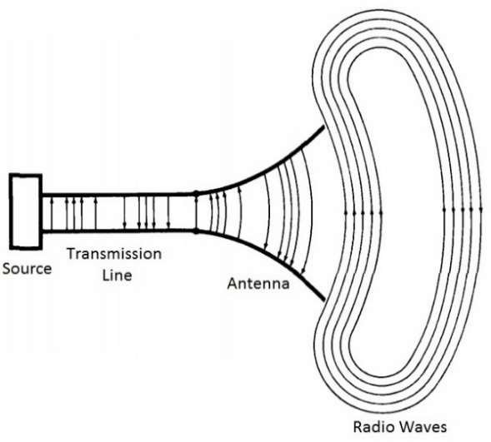

##### Fig1.1: Simple Antenna structure

Here is a list of some of the properties of antennas:

1. Field intensity for various directions (antenna pattern).
2. Total power radiated when the antenna is excited by a current or voltage of known intensity.
3. Radiation efficiency which is the ratio of power radiated to the total power.
4. The input impedance of the antenna for maximum power transfer (matching).
5. The bandwidth of the antenna or range of frequencies over which the above properties are nearly constant. All antennas may be used to receive or radiate energy.

##### TYPES OF ANTENNAS

Antennas are broadly classified in various forms:

* + - 1. Wire antenna
      2. Aperture antenna
      3. Microstrip antenna
      4. Array antenna
      5. Reflector antenna
      6. Lens antenna
      7. **WIRE ANTENNAS**

A wire antenna is an antenna that is made of a conductive wire. Wire antennas can come in different configurations and some of these configurations are dipoles, helix, and loop. Wire antennas can be seen everywhere in daily lives. A wire antenna is simply a straight wire of length λ/2 and λ/4, where λ is the transmitted signal wavelength. A wire antenna can be a loop antenna such as circular loop, rectangular loop etc.

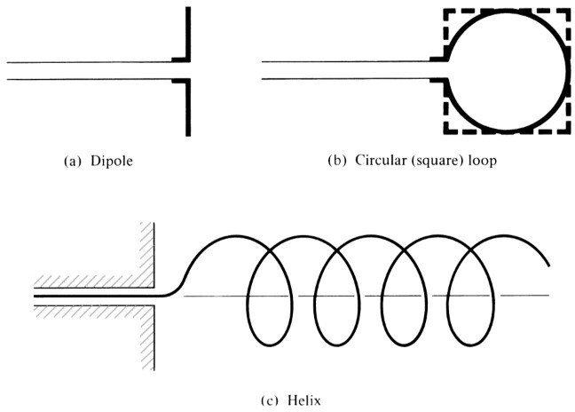

##### Fig1.2: Wire antenna configurations

* + - 1. **APERTURE ANTENNAS**

Aperture antennas are the main type of directional antennas used at microwave frequencies and above. They consist of a small dipole or loop feed antenna inside a three-dimensional guiding structure large compared to a wavelength, with an aperture to emit the radio waves. Since the antenna structure itself is no resonant they can be used over a wide frequency range by replacing or tuning the feed antenna. An aperture antenna is an antenna that contains an opening in which electromagnetic waves are transmitted or received. Aperture antennas can be many different shapes. Popular configurations of an aperture antenna are waveguides and horns. Aperture antennas are used widely in aircrafts because they can be covered with a dielectric. This dielectric protects the antenna from the

environments that an aircraft is exposed to. A waveguide is an antenna that guides an electromagnetic wave. It consists of a conductive wall that is hollow in the inside for the wave to travel. A horn antenna is “an antenna consisting of a waveguide section in which the cross- sectional area increases towards an open end which is the aperture”.

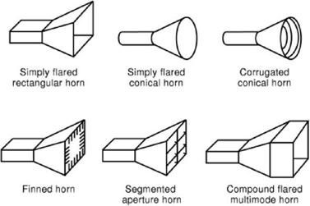

##### Fig1.3: Types of horn antenna

* + - 1. **MICROSTRIP ANTENNAS**

Microstrip antennas became very popular in the 1970s primarily for space borne applications. An individual microstrip antenna consists of a patch of metal foil of various shapes (a patch antenna) on the surface of a PCB (printed circuit board), with a metal foil ground plane on the other side of the board. Most microstrip antennas consist of multiple patches in a two- dimensional array. The antenna is usually connected to the transmitter or receiver through foil microstrip transmission lines. The radio frequency current is applied (or in receiving antennas the received signal is produced) between the antenna and ground plane. Today they are used for government and commercial applications. These antennas consist of a metallic patch on a grounded substrate. The metallic patch can take many different configurations.

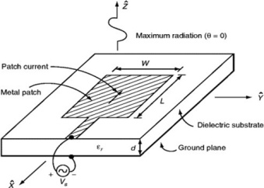

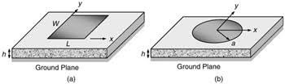

##### Fig1.4: Microstrip antennas structure (a) Rectangular and (b) Circular

However, the rectangular and circular patches are the most popular because of ease of analysis and fabrication, and their attractive radiation characteristics, especially low cross-polarization radiation. The microstrip antennas are low profile, conformable to planar and non-planar surfaces, simple and inexpensive to fabricate using modern printed-circuit technology, mechanically robust when mounted on rigid surfaces, and very versatile in terms of resonant frequency, polarization, pattern, and impedance. These antennas can be mounted on the surface of high-performance aircraft, spacecraft, satellites, missiles, cars, and even handheld mobile telephones. Ex: Rectangular, square, circular microstrip antennas, hexagon microstrip antennas, etc.

* + - 1. **ARRAY ANTENNAS**

Array antennas consist of multiple simple antennas working together as a single compound antenna. Broadside arrays consist of multiple identical driven elements, usually dipoles, fed in phase, radiating a beam perpendicular to the antenna plane. End fire arrays are fed out-of- phase, with the phase difference corresponding to the distance between them; they radiate within the antenna plane. Many applications require radiation characteristics that may not be achievable by a single element. It may however be possible that an aggregate of radiating elements in an electrical and geometrical arrangement will result in the desired radiation characteristics. The arrangement of the array may be such that the radiation from the elements adds up to give a radiation maximum in a particular direction or directions, minimum in others, or otherwise as desired. The antenna array may also be used to increase the overall gain.

Ex: Planar Dipole array antenna.

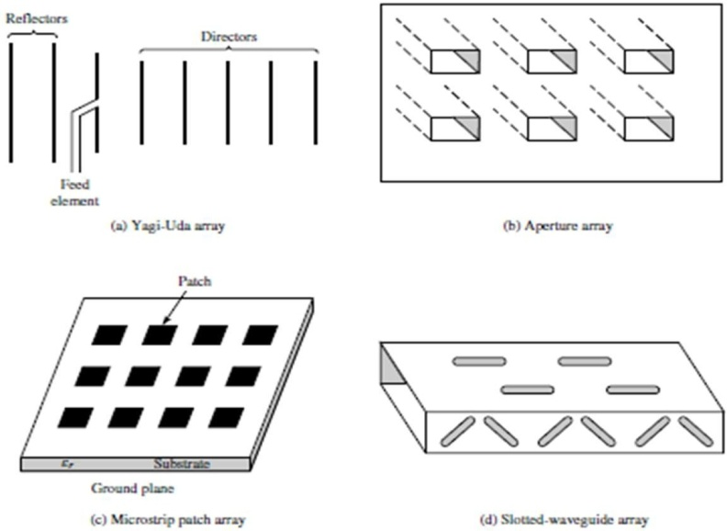

##### Fig1.5: Types of array antennas

* + - 1. **REFLECTOR ANTENNAS**

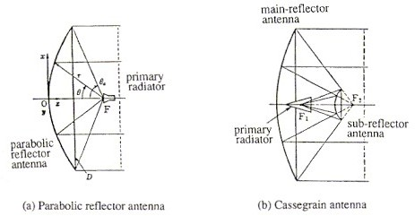An antenna reflector is a device that reflects electromagnetic waves. Antenna reflectors can exist as a standalone device for redirecting radio frequency (RF) energy, or can be integrated as part of an antenna assembly. Reflector antennas typically have high gain and low cross polarization. The simplest reflector antenna consists of two components: a reflecting surface and a much smaller feed antenna, which often is located at the reflector’s focal point. Constructions that are more complex involve a secondary reflector (a sub reflector) at the focal point, which is illuminated by a primary feed. These are called dual-reflector antennas.

##### Fig1.6: Types of reflector antennas

If a Parabolic Reflector antenna is used for transmitting a signal, the signal from the feed, comes out of a dipole or a horn antenna, to focus the wave on to the parabola. It means that, the waves come out of the focal point and strike the Paraboloidal reflector. This wave now gets reflected as collimated wave front, as discussed previously, to get transmitted.

The same antenna is used as a receiver. When the electromagnetic wave hits the shape of the parabola, the wave gets reflected onto the feed point. The dipole or the horn antenna, which acts as the receiver antenna at its feed, receives this signal, to convert it into electric signal and forwards it to the receiver circuitry.

Cassegrain is another type of feed given to the reflector antenna. In this type, the feed is located at the vertex of the paraboloid, unlike in the parabolic reflector. A convex shaped reflector, which acts as a hyperboloid is placed opposite to the feed of the antenna. It is also known as secondary hyperboloid reflector or sub-reflector. It is placed such that its one of the foci coincides with the focus of the paraboloid. Thus, the wave gets reflected twice.

* + - 1. **LENS ANTENNAS**

Lens is primarily used to collimate incident divergent energy to prevent it from spreading in undesired directions. By properly shaping the geometrical configuration and choosing the appropriate material of the lenses, they can transform various forms of divergent energy into plane waves. They can be used in most of the same applications as are the parabolic reflectors, especially at higher frequencies. Their dimensions and weight become exceedingly large at lower frequencies. Lens antennas are classified according to the material from which they are constructed, or according to their geometrical shape. The below fig shows number of lens antenna and their radiation.

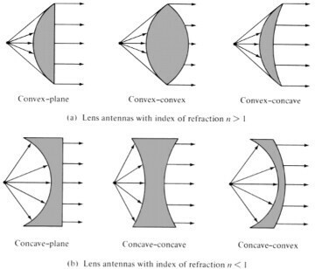

##### Fig1.7: Types of Lens antennas

Ex: Convex plane lens antenna (n>1), concave plane lens antenna (n<1). Where n is refractive index.

### INTRODUCTION

Antenna measurement techniques refer to the testing of antennas to ensure that the antenna meets specifications or simply to characterize it. Typical parameters of antennas are gain, radiation pattern, beam width, polarization, and impedance etc.

##### INPUT IMPEDANCE

For an efficient transfer of energy, the impedance of the radio, of the antenna and of the transmission cable connecting them must be the same. Transceivers and their transmission lines are typically designed for 50 Ω impedance. If the antenna has an impedance different from 50 Ω, then there is a mismatch and an impedance matching circuit is required.

##### RETURN LOSS

The return loss is another way of expressing mismatch. It is a logarithmic ratio measured in dB that compares the power reflected by the antenna to the power that is fed into the antenna from the transmission line. The relationship between SWR and return loss is the following: Return Loss (in dB)



##### BANDWIDTH

The bandwidth of an antenna refers to the range of frequencies over which the antenna can operate correctly. The antenna's bandwidth is the number of Hz for which the antenna will exhibit an SWR less than 2:1. The bandwidth can also be described in terms of percentage of the centre frequency of the band.

where FH is the highest frequency in the band, FL is the lowest frequency in the band, and FC is the centre frequency in the band. In this way, bandwidth is constant relative to frequency. If bandwidth was expressed in absolute units of frequency, it would be different depending upon the centre frequency. Different types of antennas have different bandwidth limitations.



##### DIRECTIVITY AND GAIN

Directivity is the ability of an antenna to focus energy in a particular direction when transmitting, or to receive energy better from a particular direction when receiving. In a static situation, it is possible to use the antenna directivity to concentrate the radiation beam in the wanted direction. However, in a dynamic system where the transceiver is not fixed, the antenna should radiate equally in all directions, and this is known as an omni-directional antenna.

*D*( ,)  *U* ( ,)  4 *U* ( ,)  *U* ( ,)

*Ui Prad Uaverage*

Gain is not a quantity which can be defined in terms of a physical quantity such as the Watt or the Ohm, but it is a dimensionless ratio. Gain is given in reference to a standard antenna. The two most common reference antennas are the isotropic antenna and the resonant half-wave dipole antenna. It is the ratio of the intensity in a given direction, to the radiation intensity that would be obtained if the power accepted by the antenna were radiated isotopically. The radiation intensity corresponding to the isotopically radiated power is equal to the power accepted (input) by the antenna divided by 4*π*.

**Gain=** 𝟒𝝅 𝒓𝒂𝒅𝒊𝒂𝒕𝒊𝒐𝒏 𝒊𝒏𝒕𝒆𝒏𝒔𝒊𝒕𝒚

𝒕𝒐𝒕𝒂𝒍 𝒊𝒏𝒑𝒖𝒕(𝒂𝒄𝒄𝒆𝒑𝒕𝒆𝒅)𝒑𝒐𝒘𝒆𝒓

##### RADIATION INTENSITY

Radiation intensity in a given direction is deﬁnes as the power radiated from an antenna per unit solid angle. The intensity is a field region parameter.

Near Field Region: The region between the reactive near field and the far field where the Radiation fields are dominant and the field distribution is dependent on the distance from the antenna.

Far Field Region: The region farthest away from the antenna where the field distribution is essentially independent of the distance from the antenna.

𝐔 = 𝐫𝟐𝐖𝐫𝐚𝐝

Where,

*U* = radiation intensity (W/unit solid angle)

𝑊rad= radiation density (W/𝑚2)

##### RADIATION PATTERN

The radiation or antenna pattern describes the relative strength of the radiated field in various directions from the antenna, at a constant distance. The radiation pattern is a reception pattern as well, since it also describes the receiving properties of the antenna. The radiation pattern is three-dimensional, but usually the measured radiation patterns are a two-dimensional slice of the three-dimensional pattern, in the horizontal or vertical planes. These pattern measurements are presented in either a rectangular or a polar format. The below Fig shows the radiation patter in 2-d form and 3-form in HFSS

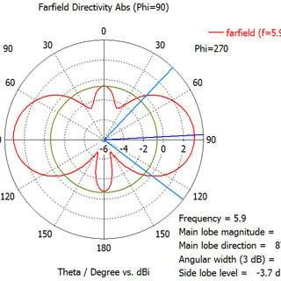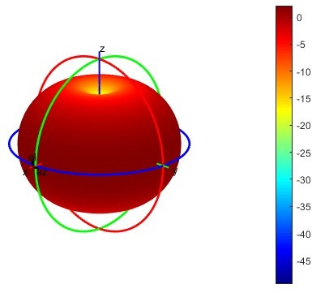

##### Fig1.8: Radiation pattern of an antenna

**LOBES**

**Major lobe or main lobe:** It is also called main beam and is defined as the radiation lobe containing the direction of maximum radiation.

**Minor lobe:** is any lobe except a major lobe.

**Side lobe:** is a lobe adjacent to the main lobe that occupies the hemisphere in direction of the main lobe.

**Back lobe:** Normally refers to a minor lobe that occupies the hemispheres in a direction opposite to that of the main lobe.

Minor lobes usually represent radiation in undesired directions and they should be minimized. Side lobes are normally the largest of the minor lobes.

##### ANTENNA EFFICIENCY

According to the standard definition, “Antenna Efficiency is the ratio of the radiated power of the antenna to the input power accepted by the antenna.”

Simply, an Antenna is meant to radiate power given at its input, with minimum losses. The efficiency of an antenna explains how much an antenna is able to deliver its output effectively with minimum losses in the transmission line. This is otherwise called as Radiation Efficiency Factor of the antenna.

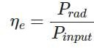

* ne is the antenna efficiency.
* Prad is the power radiated.
* Pinput is the input power for the antenna.

##### APERTURE EFFICIENCY

According to the standard definition, “**Aperture efficiency** of an antenna, is the ratio of the effective radiating area (or effective area) to the physical area of the aperture.”

An antenna has an aperture through which the power is radiated. This radiation should be effective with minimum losses. The physical area of the aperture should also be taken into consideration, as the effectiveness of the radiation depends upon the area of the aperture, physically on the antenna.

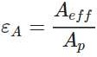

* εA is Aperture Efficiency.
* Aeff is effective area.
* Ap is physical area.

##### VOLTAGE STANDING WAVE RATIO

The ratio of the maximum voltage to the minimum voltage in a standing wave is known as Voltage Standing Wave Ratio. If the impedance of the antenna, the transmission line and the circuitry do not match with each other, then the power will not be radiated effectively. Instead, some of the power is reflected back. The higher the impedance mismatch, the higher will be the value of VSWR. The ideal value of VSWR should be 1:1 for effective radiation. Reflected

power is the power wasted out of the forward power. Both reflected power and VSWR indicate the same thing.

##### BEAM WIDTH:

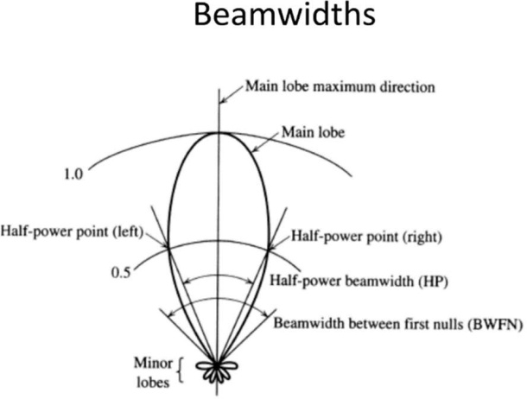It is defined as the angle which is equal to twice of the angle between first nulls. The below Fig shows the beam width.

##### Fig1.9: Some lobe terminology

* + - 1. **HALF-POWER BEAM WIDTH (HPBW):**

Beam width of an antenna is easily determined from its 2D radiation pattern and is also a very important parameter. Beam width is the angular separation of the half-power points of the radiated pattern.

* + - 1. **FIRST-NULL BEAM WIDTH (FNBW):**

The first null beam width is the angular space between the first pattern nulls adjacent to main lobe.

# Chapter 3 MICROSTRIP ANTENNA

### INTRODUCTION

The microstrip antenna is a relatively modern invention. It was invented to allow convenient integration of an antenna and other driving circuitry of a communication system on a common printed-circuit board or a semiconductor chip (Carver and Mink, 1981; Polar, 1992). Besides other resulting advantages, the integrated-circuit technology for the antenna fabrication allowed high dimensional accuracy, which was otherwise difficult to achieve in traditional fabrication methods.

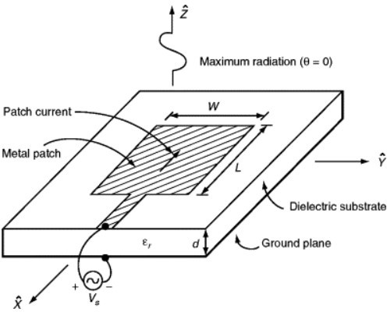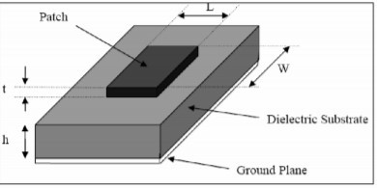A microstrip patch antenna (MPA) consists of a conducting patch of any planar or non-planar geometry on one side of a dielectric substrate with a ground plane on other side. It is a popular printed resonant antenna for narrow-band microwave wireless links that require semi- hemispherical coverage. Due to its planar configuration and ease of integration with microstrip technology, the microstrip patch antenna has been heavily studied and is often used as elements for an array. A large number of microstrip patch antennas have been studied to date. An exhaustive list of the geometries along with their salient features is available. The rectangular and circular patches are the basic and most commonly used microstrip antennas. These patches are used for the simplest and the most demanding applications. Rectangular geometries are separable in nature and their analysis is also simple. The circular patch antenna has the advantage of their radiation pattern being symmetric. The below Fig shows the microstrip antenna with length l, width w, a rectangular patch is kept on the substrate.

##### Fig3.1: Microstrip patch antenna

The microstrip antenna produces maximum radiation in the broadside (perpendicular to the substrate) direction and ideally no radiation in the end-fire (along the surface of the substrate) direction. The size of the antenna is usually designed such that the antenna resonates at the operating frequency, producing a real input impedance. For a rectangular microstrip antenna, this requires the length of the antenna, L, to be about half a wavelength in the dielectric medium. The width of the antenna, W, on the other hand, determines the level of the input impedance. The microstrip antenna can be thought of as a rectangular cavity with open sidewalls. The fringing fields through the open sidewalls are responsible for the radiation.

##### ADVANTAGES

* + - 1. Light weight and low volume.
      2. Low creation cost, subsequently can be produced in substantial amounts.
      3. Linear and circular polarization, support both.
      4. Can be effectively coordinated with microwave integrated circuit.
      5. Capable of double and triple frequency operations.
      6. Microstrip antennas are moderately cheap to produce and design as result of the basic 2-dimensional physical geometry
      7. Easy to print an array of patches on a one substrate utilizing lithographic systems.

##### DISADVANTES

* + - 1. Micro strip patch antenna suffers from more drawbacks as compared to conventional antennas.
      2. Bandwidth is narrow.
      3. Efficiency is low.
      4. Low gain.
      5. Extraneous radiation from feeds and junctions.
      6. Poor and fire radiator tapered slot antennas.
      7. Low power handling capacity
      8. Surface wave excitation.

##### APPLICATION

* + - 1. Radio altimeters
      2. Command and control system
      3. Remote sensing and environmental instrumentation
      4. Feed element in complex antennas.
      5. Satellite navigation receivers.
      6. Mobile radio.
      7. Integrated antennas.
      8. Doppler and other radars.
      9. Used in GPS.
      10. Non-satellite-based application such as medical hyperthermia

### DIFFERENT SHAPES OF MICROSTRIP PATCH ANTENNA

Microstrip antennas are also referred as patch antennas. Generally, the patch and the feed lines are photo etched on the dielectric substrate. The radiating patch may be square, rectangular, thin strip (dipole), circular, elliptical, triangular, or any other configuration. Square, rectangular, dipole (strip), and circular are the most common shapes used due to their ease of analysis and fabrication, and their attractive radiation characteristics, especially low cross- polarization radiation. Microstrip dipoles are occupying less space and give the large bandwidth which makes them attractable for arrays. Linear and circular polarizations can be achieved microstrip antennas. Scanning capability and greater directives are achieved by arrays using single or multiple feeds, the regular shapes of microstrip patch antennas are shown below.

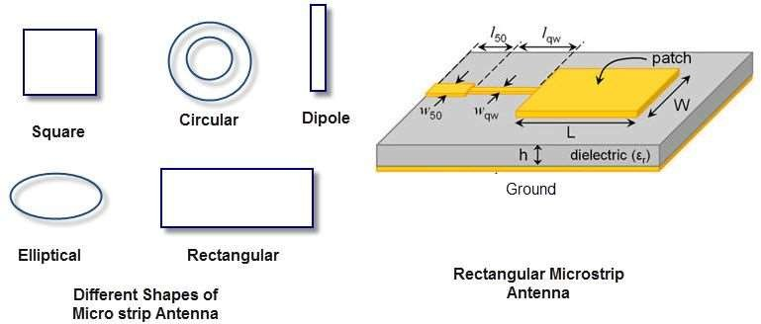

##### Fig3.2: Different shapes of microstrip patch antenna

* 1. **FEEDING METHODS**

There are mainly four basic methods for the feeding to these antennas

1. Probe Coupling Method.
2. Coaxial line feed Method
3. Aperture Coupled
4. Microstrip Feed Method
5. Proximity Coupling Method

##### PROBE COUPLING METHOD

Coupling of power to the microstrip patch antenna can be done by probe feeding method. The inner conductor of the probe line is connected to patch lower surface through slot in the ground plane and substrate material. To get perfect impedance matching we need to find out the location of the feed point over the antenna element.

Design simplicity and input impedance adjustment through feed point positioning, makes this feeding method popular. But there are some limitations also like larger lead for thicker substrate, difficulty in soldering for array elements etc.

* + - 1. Coaxial line feed possesses following characteristics:
      2. Easy to fabricate.
      3. Impedance matching is simple by controlling feed position.
      4. Spurious radiation is low (nearly -30dB).
      5. Band width is narrow (1-3%).

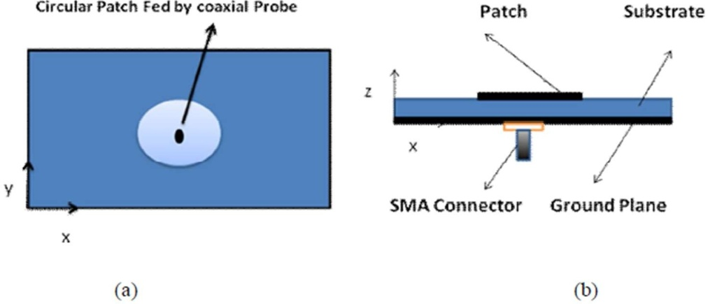

##### Fig3.3: Probe Coupling Method a) Top View b) Side View

* + 1. **APERTURE COUPLED FEED METHOD**

This method employs ground plane between two substrates. A slot will be placed on the ground plane and feed line will be placed on lower substrate. This will be electromagnetically connected to patch on the upper substrate through the ground plane slot. One should take care about substrate parameters and they have to choose in a way that feed optimization and independent radiation functioning can exist. The coupling slot should be nearly cantered so that the patch magnetic field will be maximum.

The aperture coupling feeding has following characteristics:

* + - 1. Moderate spurious radiation (nearly -20dB below ground plane).
      2. Ground plane isolates the feed from the radiator and minimizes interference.
      3. Modeling is easier.
      4. The feed and radiator design can be optimized independently.

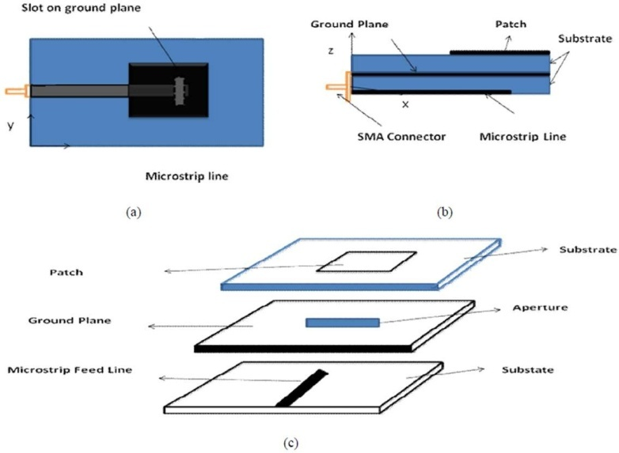

##### Fig3.4: Aperture coupled feed method Top view b) Side view c) Pictorial view

* + 1. **MICROSTRIP LINE FEED:**

Using microstrip line we can give excitation to the antenna as shown in the figure

* 1. This method is very simple to design and fabricate. But this technique suffers from some limitations. If substrate thickness is increased in the design, then the surface waves and the spurious radiation also increases. Because of that the undesired cross polarization radiation arises. Microstrip line feeding can be used in the conditions where performance of the antenna is not a strict matter. The edge coupled feed can be improved with coplanar wave guide feeding. The micro strip line feed is a conducting strip of much smaller width compared to the patch and possess following characteristics:
     1. Easy to fabricate.
     2. Impedance matching is simple by controlling inset feed position.
     3. Spurious radiation is low (nearly -20dB).
     4. The surface waves and spurious feed radiation increases with substrate height.
     5. Bandwidth is narrow (2-5%).

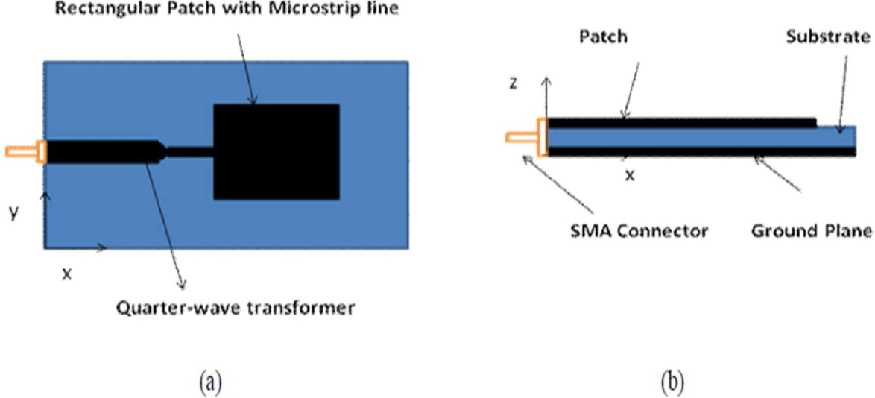

##### Fig3.5: Microstrip feeding a) Top view b) Side view

* + 1. **PROXIMITY COUPLING FEEDING:**

This method can be employed, where two or multilayer substrate configuration is considered. Generally, in this configuration, microstrip line will be placed on lower substrate and the patch element will be placed on the upper substrate. Other name for this feeding is electromagnetically coupled feed. Capacitive nature will appear between feed line and patch in this case. By choosing thin lower substrate layer and placing patch on top layer will improve the bandwidth and reduce the spurious radiation. Fabrication of this feeding is slightly difficult because of alignment problems in feed and patch at proper location. Peaceful thing is soldering and related problems can be eliminated.

Proximity coupling has following characteristics:

* + - 1. Highest bandwidth (of the order of 13%), compared with previous cases.
      2. Modelling is easier.
      3. Spurious radiation.
      4. Impedance matching can be controlled by the length of the feeding stub and width to length ratio of the patch.

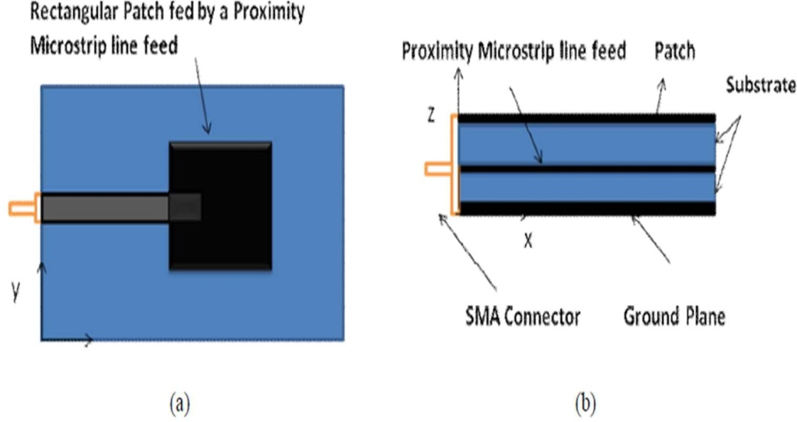

##### Fig3.6: Proximity coupled a) Top View b) Side view

* + 1. **COMPARISON OF FEEDING METHODS**

**Table: Comparison of feeding methods**

|  |  |  |  |  |
| --- | --- | --- | --- | --- |
| **CHARACTER ISTICS** | **COAXIAL PROBE FEED** | **MICROSTRIP LINE FEED** | **PROXIMITY COUPLED** | **APERTURE COUPLED** |
| **SPURIOUS FEED RADIATION** | Low | Less | More | More |
| **FABRICATIO N REUSE** | Soldering required | Easy | Alignment required | Alignment required |
| **RELIABILIT Y** | Better | Better | Good | Good |
| **IMPEDANCE MATCHING** | Easy | Poor | Easy | Easy |

* 1. **TRANSMISSION LINE MODEL:**

This model represents the micro strip antenna by two slots of width *W* and height *h*, separated by a transmission line of length L. The micro strip is essentially a non-homogeneous line of two dielectrics, typically the substrate and air. Hence, as seen from Fig 2.8, most of the electric field lines reside in the substrate and parts of some lines in air. As a result, this transmission line cannot support pure transverse-electric magnetic (TEM) mode of transmission, since the phase velocities would be different in the air and the substrate. Figure: Flow of E-field

Instead, the dominant mode of propagation would Bethe quasi-TEM mode. Hence, an effective dielectric constant (ε*eff*) must be obtained in order to account for the fringing and the wave propagation in the line. The value of ε*eff* is slightly less than ε*r* because the fringing fields around the periphery of the patch are not confined in the dielectric substrate but are also spread in the air as shown above.

The expression for ε*eff* is given by

𝜖r + 1 𝜖r − 1

12ℎ –0.5

𝜖eff = 2

2 [1 +

𝑊 ]

Where𝜖eff=Effective dielectric constant

𝜖r=Dielectric constant of substrate h=Height of dielectric substrate W=Width of the patch

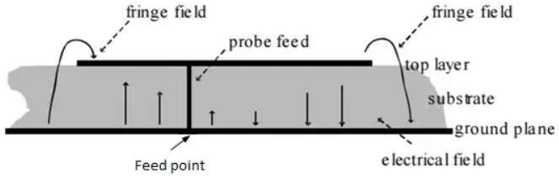

##### Fig3.7: Fields in microstrip patch antenna

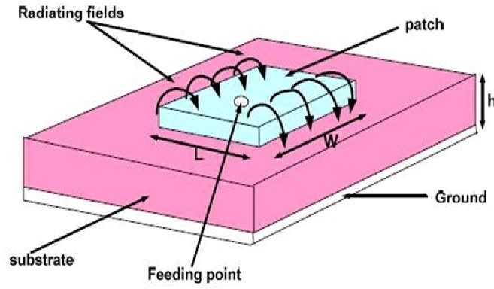Consider Fig 2.9 below, which shows a rectangular micro strip patch antenna of length *L*, width *W* resting on a substrate of height *h*. The co-ordinate axis is selected such that the length is along the x direction, width is along the *y* direction and the height is along the *z* direction. In order to operate in the fundamental *TM*10mode, the length of the patch must be slightly less than λ/2 where λ is the wavelength in the dielectric medium and is equal to λ*o*/√∈effwhere λ*o*is the free space wavelength. The *TM*10 mode implies that the field varies one λ/2 cycle along the length, and the region variation along the width of the patch.

##### Fig3.8: Microstrip Patch Antenna

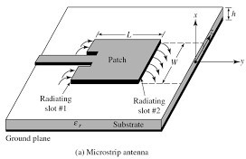In the Figure 2.10 shown below, the micro strip patch antenna is represented by two slots, separated by a transmission line of length L and open circuited at both the ends. Along the width of the patch, the voltage is maximum and current is minimum due to the open ends. The fields at the edges can be resolved in to normal and tangential components with respect the ground plane. The normal components of the electric field at the two edges along the width are in opposite directions and thus out of phase since the patch is λ/2 long and hence they cancel each other in the broad side direction.

##### Fig3.9: Top View of Antenna

The tangential components which are in phase, means that the resulting fields combine to give maximum radiated field normal to the surface of the structure. Hence the edges along the width can be represented as two radiating slots, which are λ/2 apart and excited in phase and radiating in the half space above the ground plane. The fringing fields along the width can be modelled as radiating slots and electrically the patch of the micro strip antenna looks greater than its physical dimensions.

* 1. **SLOT IN MICROSTRIP PATCH ANTENNA**

With ever increasing demand for reliable wireless communication, the need for efficient use of electromagnetic spectrum is on the rise. But also, older large phased array antenna used the principle because the slot radiators are very inexpensive way for frequency scanning array. The slot behaves according to Babinet’s principle as resonant radiator. This principle relates the radiated field and impedance of an aperture or slot antenna so that of the field of a dipole antenna. It can also provide the low profile, low cost, small size, easier integration with other circuits and conformability to a shaped surface. Numerous slot antenna design for 2.4/5 GHz dual band WLAN operations have been reported.

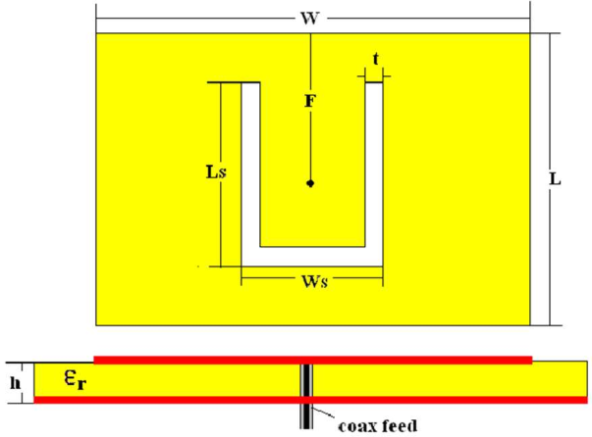

##### Fig3.10: U Slot on rectangular patch antenna

The above Fig shows the U slot on the Rectangular Patch antenna. Slot’s antenna is an about λ/2 elongated slot, cut in a conductive plate and excited in the centre. Microstrip slot antenna is simple in structure. It consists of microstrip feed that couples electromagnetic waves through the slot above and slot radiates them. A microstrip fed antenna offers a better isolation between the feed and the material under measurement compared to the microstrip fed microstrip antenna. They are more flexible in integration with other active and passive device in a hybrid MIC and MMIC design. Furthermore, they are capable of producing omnidirectional radiation patterns by simply inserting quarter wave thick foam and reflector. We find the great use of slot antennas for fixed stations satellite ground stations and beacon with proper mounting a slot antenna can also be used in microwave mobile.

##### EFFECT OF SLOTS ON BANDWIDTH

The bandwidth is usually specified as frequency range over which VSWR is less than two. Some times for stringent application the VSWR requirement. The bandwidth of the antenna increases with the help of slots. These structures are periodic in nature that forbids the propagation of all electromagnetic surface waves within a particular frequency band called bandgap thus permitting additional control of the behaviour of electromagnetic waves other than conventional guiding /filtering structure.

##### EFFECT ON SLOTS ON THE GAIN

Gain relates the intensity of antenna in a given direction to the intensity that would be produced by a hypothetical ideal antenna that radiates equally in all direction or isotopically and has no losses. By using high permittivity substrate and by different shape of slot we can enhance the gain of antenna.

##### EFFECT OF SLOTS ON RETURN LOSS

Return loss is the difference between forward and reflected power in dB generally measured at the input to the coaxial cable connected to the antenna. Selection of feeding technique for a microstrip patch antenna is important decision because it affects the bandwidth, return loss, VSWR patch size and smith chart. Using double or dual slot stacked patch technique use can get better return loss by increases the length and width of slot antenna return loss can be reduced.

##### EFFECT OF SLOT ON SIZE OF ANTENNA

With the help of slot size of microstrip patch antenna is reduced. This effect can be done by changing the path of current. When slots are cut into patch current is changed. Current travels extra patch as compare to the without slot microstrip patch antenna.

* 1. **DEFECTIVE GROUND STRUCTURE**

##### INTRODUCTION

Conventional microstrip antennas had some limitations, that is, single operating frequency, low impedance bandwidth, low gain, larger size, and polarization problems. There are number of techniques which have been reported for enhancing the parameters of conventional microstrip antennas, that is, using stacking, different feeding techniques, Frequency Selective Surfaces (FSS), Electromagnetic Band Gap (EBG), Photonic Band Gap (PBG), Metamaterial, and so forth. Microwave component with Defected Ground Structure (DGS) has been gained popularity among all the techniques reported for enhancing the parameters due to its simple structural design. DGS has been used underneath the microstrip line to achieve band-stop characteristics and to suppress higher mode harmonics and mutual coupling. After successful implementation of DGS in the field of filters, nowadays DGS is in demand extensively for various applications. This paper presents the evolution and development of DGS. The basic concepts, working principles, and equivalent models of different shapes of DGS are presented. DGS has been used in the field of microstrip antennas for enhancing the bandwidth and gain of microstrip antenna and to suppress the higher mode harmonics, mutual coupling between adjacent element, and cross-polarization for improving the radiation characteristics of the microstrip antenna. Defected Ground Structure (DGS) firstly and used the term “DGS” in describing a single dumbbell shaped defect. The DGS can be regarded as a simplified form of EBG structure, which also exhibits a band-stop property.

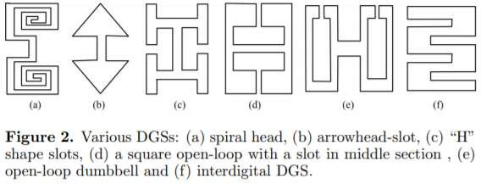

**Fig3.11:**

##### WORKING

DGS has been integrated on the ground plane with planar transmission line, that is, microstrip line, coplanar waveguide, and conductor backed coplanar wave guide The defects on the ground plane disturb the current distribution of the ground plane; this disturbance changes the characteristics of a transmission line (or any structure) by including some parameters (slot resistance, slot capacitance, and slot inductance) to the line parameters (line resistance, line capacitance, and line inductance). In other words, any defect etched in the ground plane under the microstrip line changes the effective capacitance and inductance of microstrip line by adding slot resistance, capacitance, and inductance. The below Fig shows the spiral DGS on PCB it is acting as band pass filter.

##### ADVANTAGES OF DGS:

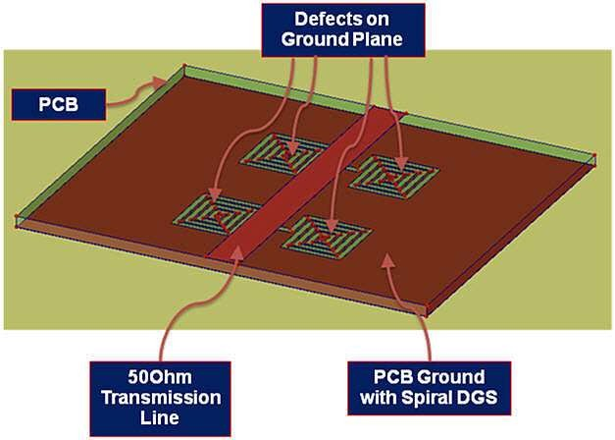

**Fig3.12: Spiral DGS on PCB**

The main advantages of DGS are that it introduces slow wave effect. This effect produced because of the DGS equivalent and components. The transmission line with DGS gives higher effective impedance and also introduces high slow wave effect, which provides rejection band in some frequency range. The microstrip line with DGS has a large electrical length as compared to conventional microstrip for the same physical length. Thus, DGS helps to lower resonance frequency and therefore to reduce the size of an antenna. DGS structures are used in RF/microwave components (filters, dividers, amplifiers and high-speed digital designs.

However, designing DGS structures can be tricky. Design tools typically don’t include closed- form DGS circuit models, so EM simulation is required to analyze and optimize these structures to meet the design goals.

##### APPLICATIONS OF DGS:

DGS is widely used nowadays in active and passive devices. Each DGS shape has its own characteristics and creates effect on the performance of the device according to its geometry and size. DGS has been used in filters, coplanar waveguides, microwave amplifiers, and antennas to improve their performance. DGS is used for miniaturizing the size of component, enhancing the operating bandwidth and gain, reducing the mutual coupling between two networks, suppressing the higher order harmonics and unwanted cross-polarization, and also producing notched band to stop interference with any band.

* + - 1. **FILTERS**

Numerous DGS shapes have been reported to design planar circuits. Different shapes of DGS have been explored to design bandpass and band-stop planar filters. Initially, a dumbbell shaped the below Fig shows the low pass filter using DGS and its frequency curve.

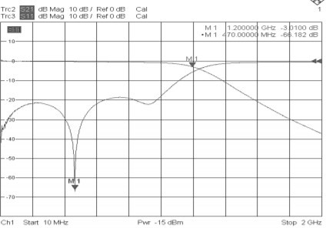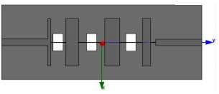

##### Fig3.13: Effect of filters

DGS was embedded in the ground plane underneath a microstrip line for creating a filter response. It perturbs the electromagnetic fields around the defect and trapped electric fields give rise to the capacitive effect, while the surface currents around a defect cause an inductive effect. This, in turn, results in resonant characteristics of a DGS, causing an effect of filters.

* + - 1. **COPLANAR WAVEGUIDES**

Recently, a great trend towards the implementation of a reconfigurable DGS, where the location of the transmission zeros can be controlled and tuned, may be seen from a number of recent publications. In addition to this, DGS unit cell has been proposed on coplanar waveguide. Several studies have been reported in this regard. Coplanar waveguides having band-stop performance have been proposed with DGS using SIW technique. The below Fig show the spiral DGS that are used in coplanar waveguide, on the left side Fig(a): is equivalent circuit and Fig(b): prototype of one pole Butterworth band rejection filter.

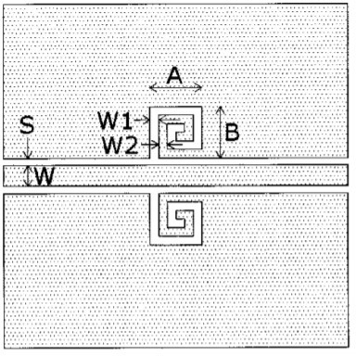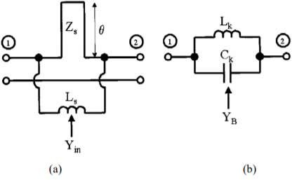

##### Fig3.14: Spiral DGS for coplanar waveguides

* + - 1. **AMPLIFIERS**

DGS also has been employed with planar microwave amplifiers. A series of dumbbell DGS has been embedded on the ground plane underneath the microstrip line to improve the efficiency and to tune the harmonics of power amplifier.

* + - 1. **ANTENNAS**

In the early phases of the development of DGS, a majority of DGS shapes were explored to design microstrip filters, and these applications inspired the antenna engineers to realize planar antenna with stop band characteristics by integrating DGS on their ground plane. DGS has been used for improving the various parameters of the conventional planar antenna.

### EBG

##### INTRODUCTION

EBGs are periodic arrangements of dielectric or metallic elements in one-, two-, or three- dimensional manner. A periodic structure can give rise to multiple band gaps since the band gap is not only due to the periodicity of the structure but also due to the individual resonance of one element. The band gap formation in EBG is due to the interplay between macroscopic and microscopic resonances of a periodic structure. The periodicity governs the macroscopic resonance or the Bragg resonance, the lattice resonance, whereas the microscopic resonance is due to the element characteristics, and it is called the Mie resonance.

When the two resonances coincide, the structure possesses a band gap having maximum width. Depending on the structural characteristics and polarization of the wave, one of the stop band resonance mechanism can dominate over the other. At the stop band, the structure will reflect back all electromagnetic waves, whilst at other frequencies it will act as a transparent medium. Besides the band gap feature, EBG also possesses some other exciting properties, such as high impedance and AMC. For example, a mushroom-like EBG surface exhibits high surface impedances for both TE and TM polarizations.

When a plane wave illuminates the EBG surface, an in-phase reflection coefficient is obtained resembling an artificial magnetic conductor. In addition, soft and hard operations of an EBG surface have also been identified in the frequency-wave number plane. These interesting features have led to a wide range of applications in antenna engineering, from wire antennas to microstrip antennas, from linearly polarized antennas to circularly polarized antennas, and from the conventional antenna structures to novel surface wave antenna concepts and reconfigurable antenna designs.

##### TYPES OF EBG

* + - 1. **SINGLE BAND EBG**

In this section, three different types of single band EBGs are proposed. The new EBGs are cross hair type, Swastika type and hexagonal patch type. Finally, the resonance frequencies and bandwidths of the three new EBGs are compared with standard mushroom type EBG. The analyses of all the EBGs have been done by using microstrip line method. First, the ground plane is printed on one side of the substrate and the EBG array (with via) on the other side. Next, on another substrate, a 50 ohms line is printed without ground and the two structures are stacked as shown in. Then the two ends of the 50 ohms line are connected to two ports and the S21 is measured using proper excitation.

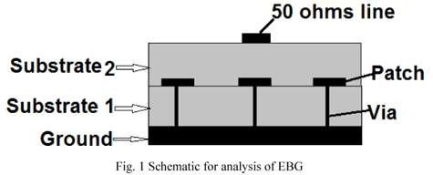

##### Fig3.15: Demonstration of Single band EBG

* + - 1. **MUSHROOM TYPE EBG**

Mushroom type EBG is a conventional three-dimensional EBG consisting of a solid patch with a cylindrical via. The transmission response of mushroom type EBG depends upon the size of the patch, diameter of via and the gap between the unit elements. The transmission characteristic also depends upon the thickness of the substrate and the substrate material used. Shows a mushroom type EBG and its equivalent circuit model. shows the variation of the transmission response of the mushroom type EBG with different unit element (patch) sizes. The gap between the unit elements is taken as 1 mm, the via diameter 0.6 mm and the substrate thickness is 0.8 mm. It can be seen from figure that as the patch size increases, the stop band shifts towards the lower frequency side and this is due to an increase in the capacitance value.

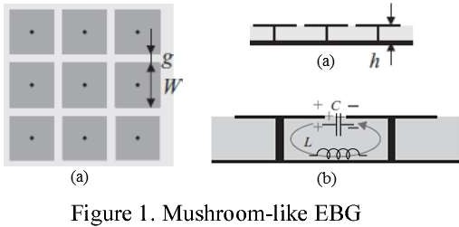

**Fig3.16:**

* + - 1. **CROSS HAIR TYPE EBG**

It is made by modification of the mushroom type EBG. It consists of a patch and a number of microstrip lines. The microstrip lines provide extra inductance as compared to the mushroom type EBG. The transmission response of this EBG depends upon the width of the microstrip lines and gap between the unit elements. shows the variation of the transmission response of a cross hair type EBG for different widths of the microstrip lines used. As the width increases, the resonance frequency shifts towards the higher frequency side due to a decrease in the inductance value.

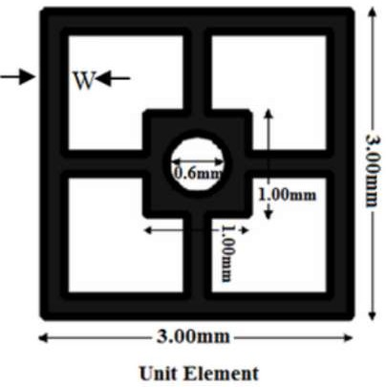

##### Fig3.17: Crosshair type EBG

**Chapter 4 PENTAGONAL SHAPED**

**UWB ANTENNA**

* 1. **UWB INTRODUCTION**

**Ultra-wideband** (**UWB**, **ultra-wideband**, **ultra-wide band** and **ultra-band**) is a radio technology that can use a very low energy level for short-range, high-bandwidth communications over a large portion of the radio spectrum. Ultra-wideband (UWB) is a short- range wireless communication protocol—like Wi-Fi or Bluetooth—uses radio waves of short pulses over a spectrum of frequencies ranging from 3.1 to 10.5 GHz in unlicensed applications. The term UWB is used for a bandwidth (BW) that is larger or equal to 500 MHz or a fractional bandwidth (FBW) greater than 20It will be preferred that an antenna has bandwidth in excess of frequency range from 800 MHz to 11 GHz or even more, to include all the existing wireless communication systems such as AMPC800, GSM900, GSM1800, PCS1900, WCDMA/UMTS (3G), 2.45/5.2/5.8-GHz-ISM, U-NII, DECT, WLANs, European Hiper

LAN I, II, and UWB (3.1–10.6 GHz) . The information can also be modulated on UWB signals (pulses) by encoding the polarity of the pulse, its amplitude and/or by using orthogonal pulses. UWB pulses can be sent sporadically at relatively low pulse rates to support time or position modulation, but can also be sent at rates up to the inverse of the UWB pulse bandwidth. The different frequency are shown in below fig and different shape of antenna used in UWB.

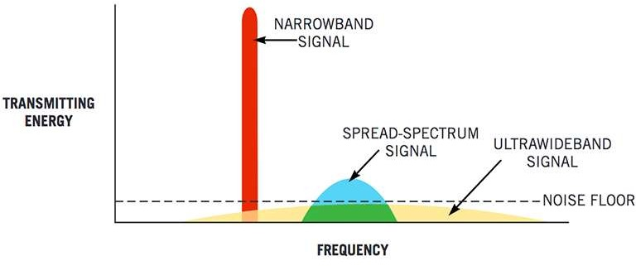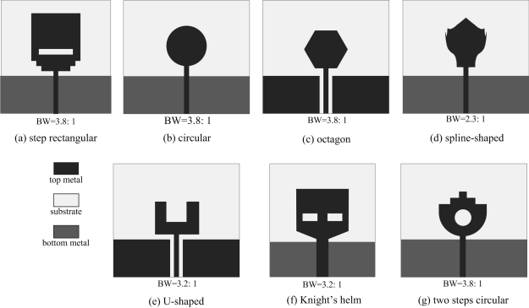

##### Fig4.1: Ultra-wide band frequency band UWB antennas with different shape

The imminent widespread commercial deployment of ultra-wideband (UWB) systems has sparked renewed interest in the subject of ultra-wideband antennas. The power levels authorized by the FCC mean that every dB counts in a UWB system - as much or perhaps even more so than in a standard narrowband system. Thus, an effective UWB antenna is a critical part of an overall UWB system design. UWB antennas have been in active commercial use for decades. This is a particularly stark example, but it highlights the difficulty with traditional UWB antennas: they are typically “multi-narrowband” antennas instead of antennas optimized to receive a single coherent signal across their entire operating bandwidth. Some modulation schemes are more tolerant of antenna variations than others. For instance, a multi-band or OFDM approach may be less vulnerable to dispersion or other variations across an antenna’s operational band. Nevertheless, a UWB system requires an antenna capable of receiving on all frequencies at the same time.

### TYPES OF UWB ANTENNAS

Many specific kinds of UWB antennas fall within these general categories. Directional antennas include horn and reflector antennas. These antennas can also be implemented in relatively compact planar designs. Small element antennas such as dipoles or loops are preferred for omni-directional coverage or where space is at a particular premium. Traditional “frequency independent” antennas like log periodic or spiral antennas tend to be larger in size and can be used only if waveform dispersion across the field of view may be tolerated. UWB antennas may also be combined in arrays.

##### PRINTED MONOPOLE ANTENNA:

Another versatile antenna which has large attention recently is printed monopole antenna. They offer large bandwidth and are more attractive for wireless communication applications. The large ground plane used for the conventional printed monopole is the main limitation. However, the move towards the truncated ground plane has made the antenna low profile and suitable for integration into circuit board as terminal antennas. Recently printed antennas have received much attention due to their low profile and omni- directional radiation characteristics. The rapid growth of ultra-wide band communication demands ultra-wide band antennas to accommodate large frequency spectrum of ultra- short pulse used for this communication. There is a growing demand for small and low cost UWB antennas that can provide satisfactory performances in both frequency domain and time domain.

Recently monopoles with elliptical, Square(rectangular), bow-tie diamond and trapezoidal sheets, have been designed and investigated. Compared with traditional wire antennas, printed dipole antennas have extra advantages including planar structure, small volume, light weight and low cost, which are significantly suitable for applications sensitive to the receiver sizes. Recently, various types of printed dipole antennas have been studied to comply with the compact high-performance broad band/multi band requirements.

##### FINITE ELEMENT METHOD (FEM):

The finite element method is one of the classic tools of numerical analysis, suitable for the solution of a wide class of partial differential or integral equations. In the mid 1970’s Mei, Morgan and change introduced the finite element approach for the Helmholtz equation. Later, in the early 1980’s, they shifted their finite element research to direct solutions of maxwell’s curl equations. Finite element techniques require the entire volume of the configuration to be meshed as opposed to surface integral techniques, which require only the surfaces to be meshed. Each mesh element has completely different properties from those of the neighbouring elements. In General, Finite element techniques excel at modelling complex inhomogeneous configurations. However, they do not model

unbounded radiation problems effectively as moment method techniques. In general, Finite element techniques excel at modelling complex inhomogeneous configurations. However, they do not model unbounded radiation problems as effectively as moment method techniques.

The first step in finite element analysis is to divide the configuration into a number of small homogenous pieces or elements. The model contains information about the device geometry, material constants, excitations and boundary constraints. In each finite element, a simple (often linear) variation of the field quantity is assumed. The corners of the elements are called nodes. The goal of the finite-element analysis is to determine the field quantities at the nodes. Generally, finite element analysis techniques solve for the unknown field quantities by minimizing an energy functional. The energy functional is an expression describing all the energy associated with the configuration being analysed. For 3-dimensional time harmonic problems this functional may be represented as

𝛍|𝐇𝟐|

𝛜|𝐄𝟐| 𝐉. 𝐄

𝐅 = ƒ ( 𝟐 +

− ) 𝐝𝐯

𝟐 𝟐𝐣𝐰

The first two terms represent the energy stored in the magnetic and electric fields, and the third term is the energy dissipated by the conduction current. Expressing ‘H’ in terms of ‘E’ and setting the derivative of this functional with respect to E=0, and equation of the form f (J, E) =0 is obtained. At Kth order approximation of the function f is then applied at each node and boundary conditions enforced, resulting in the system of equations

[𝐉] = [𝐘][𝐄]

The elements of J are referred to as the source terms, representing the known excitations. The elements of the Y-matrix are functions of the problem Geometry and boundary constraints. The elements of the E matrix represent the unknown electric field at each node, obtained by solving the systems of equations. In order to obtain a unique solution, it is necessary to constrain the values of the field at all boundary nodes. Therefore, a major weakness of FEM is that it is relatively difficult to model open configurations. However, in finite element methods, the electric and geometric properties of each element can be defined independent. This permits the problem to be set up with a large number of small elements in region of complex geometry and fewer, larger elements in relatively open regions. Thus, it is possible to model complicated geometries with many arbitrarily shaped dielectric regions in a relatively efficient manner.

## APPLICATIONS OF UWB

##### RADAR SYSTEMS

For radar applications, these short pulses provide very fine range resolution and precision distance and positioning measurement capabilities. The very large bandwidth translates into superb radar resolution, which has the ability to differentiate between closely spaced targets. This high resolution is obtained even through lossy media such as foliage, soil and wall and floor of the buildings. Other advantages of UWB short pulses are immunity to passive interference (rain, fog, clutter, aerosols, etc) and ability to detect very slowly moving or stationary targets. UWB antennas arrays are especially important, to have both fine range and angular resolution in radars. In radar cross-section (RCS) range, a single UWB antenna replace a large set of narrow band antennas that are normally used to cover the whole frequency band of interest. UWB signals enable inexpensive high-definition radar. Radar will be used in areas currently unthinkable such as; automotive sensors, smart airbags, intelligent highway initiatives, personal security sensors, precision surveying, and through the wall public safety application. Operation of vehicular radar in the 22 to 29 GHz band is permitted under the UWB rules using directional antennas on automobiles. These devices are able to detect the location and movement of the objects near a vehicle, enabling features such as near collision avoidance, improved air bag activation, and suspension systems that better respond to road conditions.

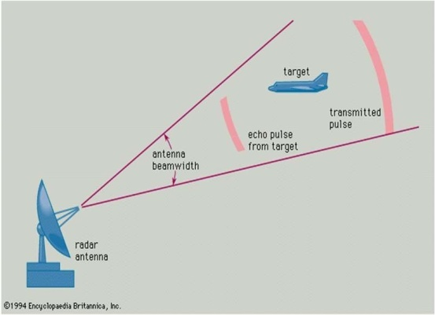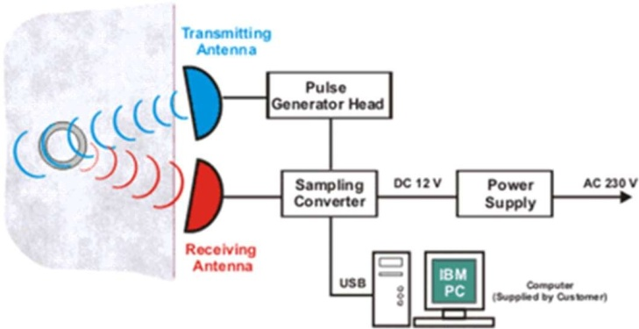

##### Fig4.2: Simple RADAR system

* + 1. **PATIENT MOTION MONITORING**

Because of the highly intense pulses used in UWB technology, it is possible to use UWB radar in medical field for remote monitoring and measuring the patients' motion in short distance. This monitoring function could be applied in intensive care units, emergency rooms, home health care, paediatric clinics (to alert for the Sudden Infant Death Syndrome, SIDS), rescue operations (to look for some heart beating under ruins, or soil, or snow). For example, in the usage of UWB in monitoring the patient in intensive care unit could avoid usage of too many wires around the patient.



##### Fig4.3: Patient monitoring system setup

Intensive Care Unit monitoring using UWB In signals emitting from UWB radars setting on ceiling can reflect when they meet human body. When the patient moves, the reflected signals will fluctuate. The fluctuation of signals denoting the movement of objects is transferred to the control centre of the surveillant. The information could be fed back instantaneously to the doctors or nurses. It could also be recorded and analysed in the future for the health condition of the patient. A sample of the results of this application is shown in the Fig 3 [Xu07]. The pulse amplitude fluctuation shows that there is movement of the patient in the room. The higher the pulse amplitude is, the closer the person move to the UWB radar. The application could be used to monitor the patients whether moving in the unallowed time. UWB radar could measure the speed and position of the patient in the room.

##### OBSTETRICS IMAGING

Another possible medical imaging application of UWB radar is in obstetrics imaging, shown as in Fig However, unfortunately great concern regarding the RF safety in UWB for the new born exists although everybody thinks the ultrasound generally is safe. The "emissions" from the device make this concern a "fear generating" situation. Obviously, more time is needed for everyone could accept the UWB radar. In the future, UWB radar device for obstetrics will be very useful and might be produced in large scale sales. Actually, UWB radar emission is safe and the system is well suited for chronically positioned equipment to monitor the last period of pregnancy or to assist in evaluating labour progress. UWB radar in this application area has many advantages over current ultrasound based foetal monitoring system. These new features

include: no contact with patient, unimpaired mother and child care, remote operation, no cleaning and easier use.

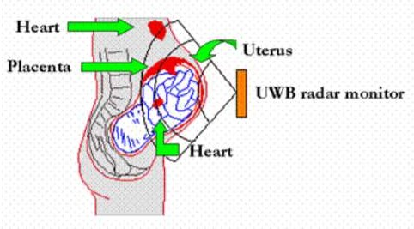

##### Fig4.4: Patient monitoring system

* + 1. **COMMUNICATION SYSTEMS**

Using UWB techniques and the available large RF bandwidths, UWB communication links has become feasible. The exceptionally large available bandwidth is used as the basis for a short-range wireless local area network with data rates approaching gigabits per second. This bandwidth is available at relatively low frequencies thus the attenuation due to building materials is significantly lower for UWB transmissions than for millimetre wave high bandwidth solutions. By operating at lower frequencies, path losses are minimized and the required emitted power is also reduced to achieve better performance. Computer peripherals offer another fitting use of UWB, especially when mobility is important and numerous wireless devices are utilized in a shared space. A mouse, keyboard, printer, monitor, audio speakers, microphone, joystick, and PDA are in wireless. UWB also is used as the communication link in a sensor network. A UWB sensor network frees the patient from the tangle of wired sensors. Sensors are being used in medical situation to determine pulse rate, temperature, and other critical life signs.

UWB is used to transport the sensor information without wires, but also function as a sensor of respiration, heartbeat, and in some instance for medical imaging. UWB pulses are used to provide extremely high data rate performance in multi-user network applications. These short duration waveforms are relatively immune to multipath cancellation effects as observed in mobile and in-building environments. In addition, because of the extremely short duration waveforms, packet burst and time division multiple access (TDMA) protocols for multi-user communications are readily implemented.

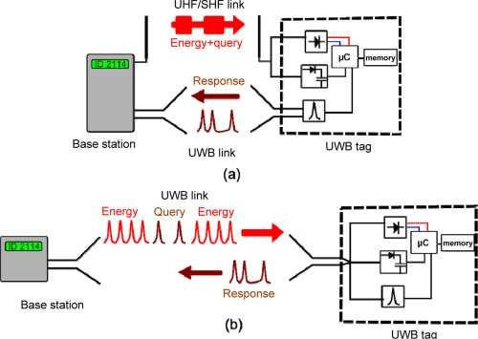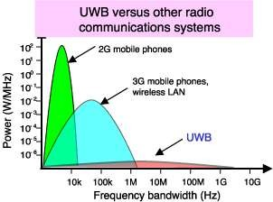

##### Fig4.5: UWB in communication systems

* 1. **INTRODUCTION TO PENTAGON ANTENNA**

In this paper, a novel design of a pentagonal shape UWB antenna embedded with a modified V-shaped slot and hexagon-shaped electromagnetic band gap (EBG) structures, placed near the microstrip feed line. For the frequencies from 3.1 to 11 GHz, an input impedance (Zin) response for return loss (S11) < −10 dB is obtained. The surface current distributions in pentagonal structure are studied for carrying out the identification of its resonant modes. Later, using an optimized pentagon-shaped UWB antenna, with a modified V-shaped slot and hexagon-shaped electromagnetic band gap structures, a notch response over one frequency bands, i.e., at 5–6 GHz, is realized. Here the addition of modified V-shaped slots in pentagonal shape antenna changes the resonance frequencies and input impedance (Zin) at TM21 mode which results in notch response in WLAN, IEEE 802.11a, HIPERLAN/2 band.

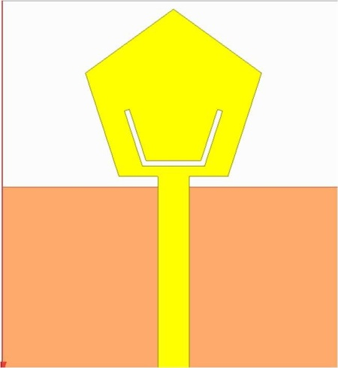

##### Fig4.6: Pentagonal UWB antenna with V shaped slot

In the lower frequency band, tunable band notch characteristics are obtained by changing the length of modified Rectangular-shaped slots. In the higher band, the same is realized either by varying the side length of hexagonal EBG structures or by changing the shorting via position on the EBG unit. The return loss of greater than −5 dB is realized ensuring more than 55% of the reflected power over the notch band frequencies. The presented antennas were optimized on a low-cost glass epoxy substrate by using High Frequency Structure Simulator (HFSS), The time domain analysis of the proposed antenna is also carried out. The tunable band notch benefits the reduction of interference with simultaneous applications such as Bluetooth, Wi-Fi, and Wi-MAX.

##### DESIGN METHODOLOGY:

In order to make a pentagonal shaped UWB antenna with slot and EBG following requirement have to be fulfilled by the designer and to fabricate its design

* + - 1. Choosing the appropriate substrate.
      2. Choosing candidate radiator geometry.
      3. Calculating the initial geometrical parameters based on the empirical formulas.
      4. Simulating the antenna behavior over a slightly extended bandwidth and detailed analysis of results.
      5. Changing the parameters according to intuition and iteration of the previous step until getting generally satisfactory results for the performance over the entire band but especially for the lower band or deciding to change the candidate geometry.
      6. Applying the proper bandwidth-enhancement techniques to obtain UWB characteristics.
      7. Conducting parametric studies to find out which parameters affect the antenna performance and hence starting the optimization process.
      8. After successful simulation, obtaining the results, such as return loss and radiation patterns and gain.
      9. Fabrication of the antenna, measuring the return loss and radiation patterns to confirm simulated results.

##### ANTENNA DESIGN

A regular pentagonal shape UWB antenna, as shown in Figures (a) and (b), is designed on a low cost FR4 substrate (h = 1.6 mm, εr = 4.3, and tan δ = 0.02). The pentagonal patch having side length ‘s’ = 10.5 mm is selected such that its fundamental TM11 mode frequency is around

2.7 GHz while lower band edge frequency is around 2.92 GHz. A feed microstrip line having width of 3 mm for 50 Ω impedance, backed by the ground plane having dimensions ‘Lg’ = 18 mm and ‘Wg’ = 33 mm, has been selected. The horizontal separation between the patch and ground plane (p) is taken equal to 1 mm, which yields optimum bandwidth. For the frequencies from 2.7 to 11 GHz.

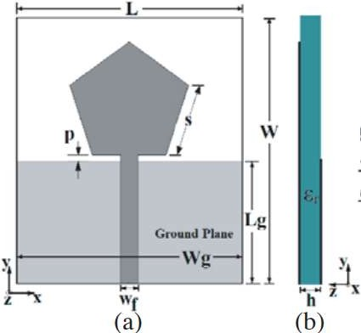

##### Fig4.7: Pentagonal patch antenna

Based on the surface current distribution at TM21 mode, the position of a modified V-shape slot in pentagonal patch is selected which will perturb its impedance and frequency to realize lower band notch response. The slot position is selected in such a way that it effectively perturbs the current in the patch present at TM21 mode. As the slot dimension is increased, the resonant frequency corresponding to TM21 mode gets lowered significantly, and the input impedance at this mode gets increased beyond 200 Ω.

Next hexagonal EBG structure is placed near microstrip feed line to help realize higher band notch response. The effect of a modified V-shaped slot is investigated in detail first by analyzing the resonance curve plot of the antenna in absence of hexagonal EBG structure. The modified V-shaped slot has horizontal slot length as ‘Lh’ and inclined slot length as ‘Lv’. The total slot length is Lh + 2 ∗ Lv = Ls. The unit cell parameters are taken as: substrate dielectric constant ‘εr’ = 4.4, substrate height ‘h’ = 1.6 mm, hexagonal patch side ‘a’ = 3 mm, diameter of each via ‘d’ = 0.5 mm of each via ‘d’ = 0.5 mm.

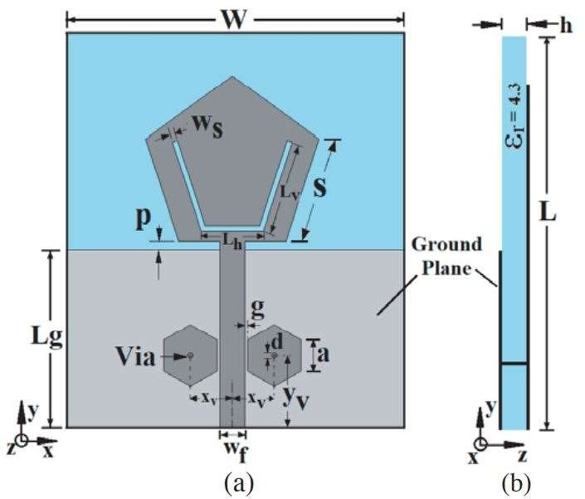

##### Fig4.8: Pentagonal patch antenna with patch and EBG

* + 1. **DESIGN EQUATIONS**

**Step1**: Calculation of the Circumradius:

𝜋𝑟2

𝑟2 =

2

1

2.37

Here, r1 is the circumradius and r2 is length of side of pentagon.

**Step2**: Calculation of the Effective dielectric constant (€r): This equation gives the effective dielectric constant.

–𝟏

#### 𝜺 = 𝜺𝒓 + 𝟏 + 𝜺𝒓 − 𝟏 [𝟏 + 𝟏𝟐 𝒉] 𝟐 , 𝒘 > 𝟏

𝒓𝒆𝒇𝒇 𝟐 𝟐

#### 𝒘 𝒉

**Step3:** Calculation of the Width of patch (L):

𝒄𝒐

#### 𝑾 = 𝟐𝒇

𝒓

J

𝒓

𝜺

𝟐

#### + 𝟏

**Step4:** Calculation of the Length of patch (L):

𝒄𝒐

#### 𝑳 = + 𝟐∆𝑳

𝟐𝒇𝒓ƒ𝜺𝒓𝒆𝒇𝒇

#### **Step5:** Calculation of the increase in size of the antenna due to fringing (∆L)

∆𝑳

= 𝟎. 𝟒𝟏𝟐

(𝜺

𝒓𝒆𝒇𝒇

𝒉

#### + 𝟎. 𝟑

) (𝒘 + 𝟎. 𝟐𝟔𝟒)

𝒉 (𝜺

𝒉

𝒓𝒆𝒇𝒇

#### − 𝟎. 𝟐𝟓𝟖) (𝒘 + 𝟎. 𝟖)

##### 4.4.4. DESIGN PARAMETERS

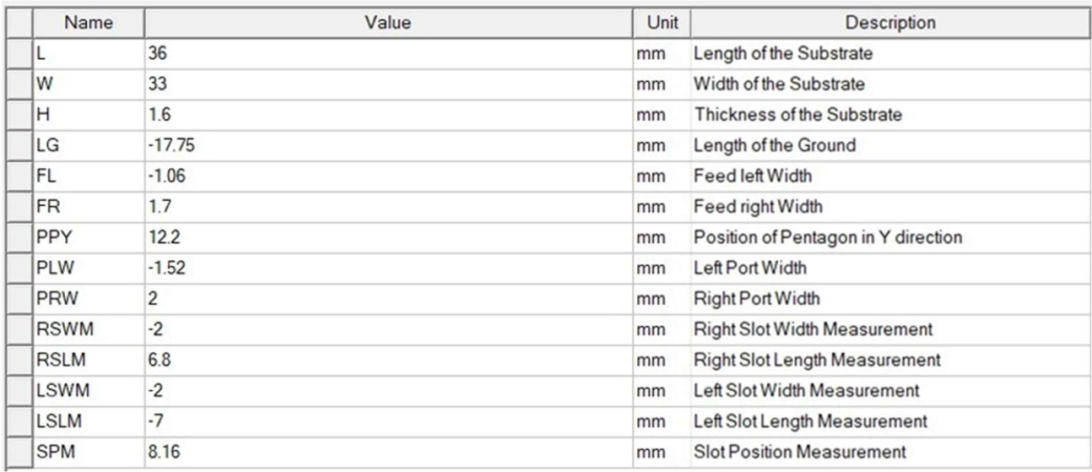

* 1. **SIMULATION**
     1. **HIGH FREQUENCY STRUCTURE SIMULATOR**

HFSS is high frequency structure simulator it is high performance full wave electromagnetic field simulator 3D volumetric passive device modelling that takes advantages of familiar Microsoft Windows graphical user interface .it integrates simulation, visualization, solid modelling and automaton in easy to learn environment. A key feature of HFSS is automatic adaptive mesh refinement which generates an accurate solution based on the physics or electromagnetics of the design. This automated meshing technique leaves the focus on the antenna design rather than spending time determining and creating the best mesh. This automation and guaranteed accuracy differentiate HFSS from all other electromagnetic simulators, which typically require manual user controls to ensure that the generated mesh is suitable and accurate for simulation. It employs the finite element method (FEM) to simulate any arbitrary three-dimensional structure by solving Maxwell's equations based on the specified boundary conditions, port excitations, materials, and the particular geometry of the structure.

##### INSTALLING HFSS

Double click on installation file and click on “Install Electromagnetics Suite” and follow the process shown in the figures below:



##### Fig4.9: Installing ANSYS

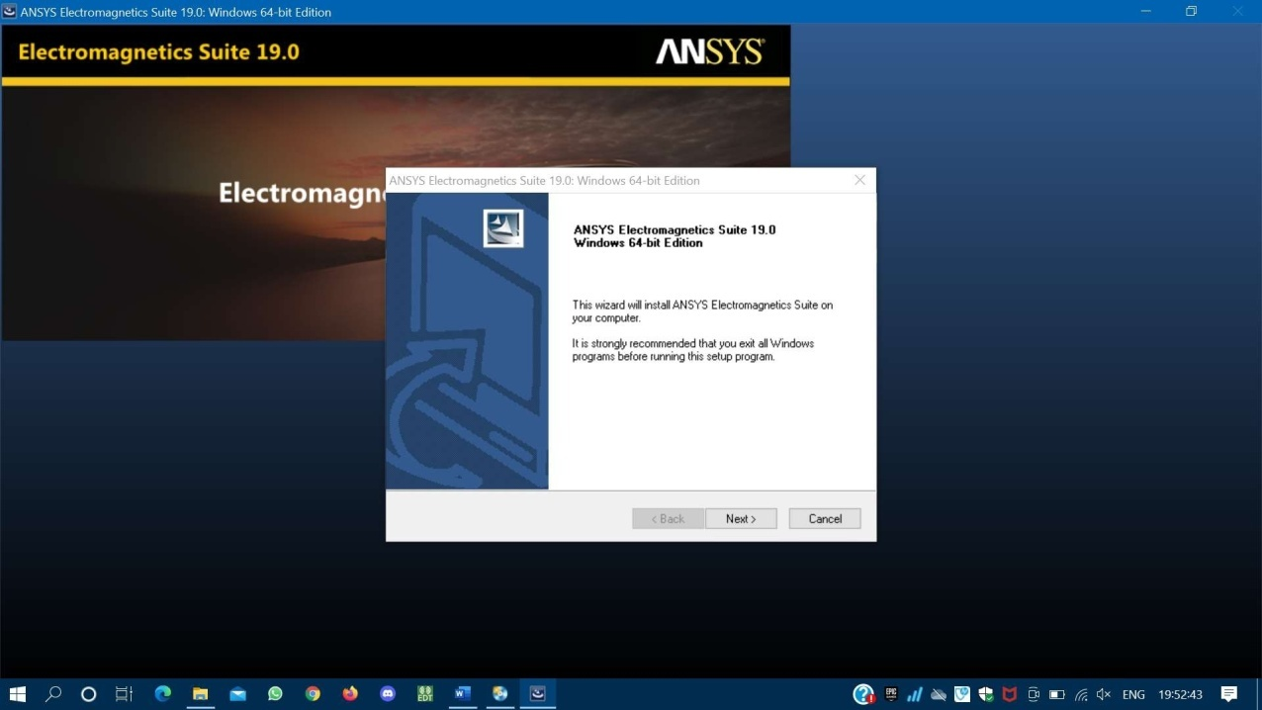

**Fig4.10: Step2 of installation**

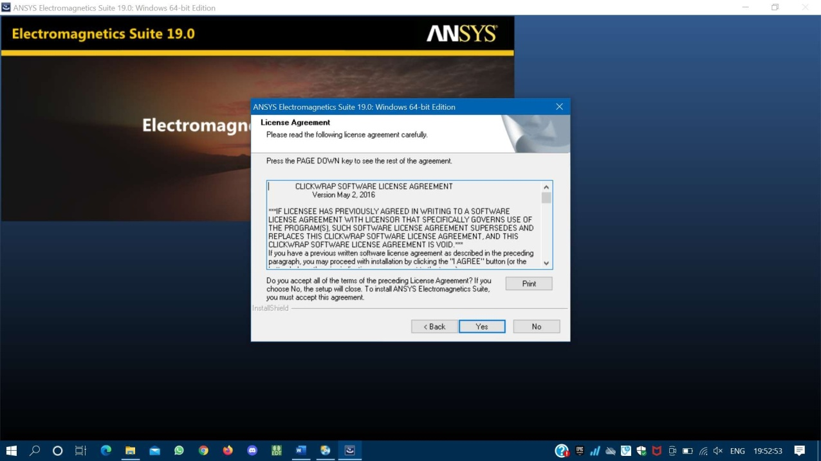

**Fig4.11: Read the agreement of ANSYS**

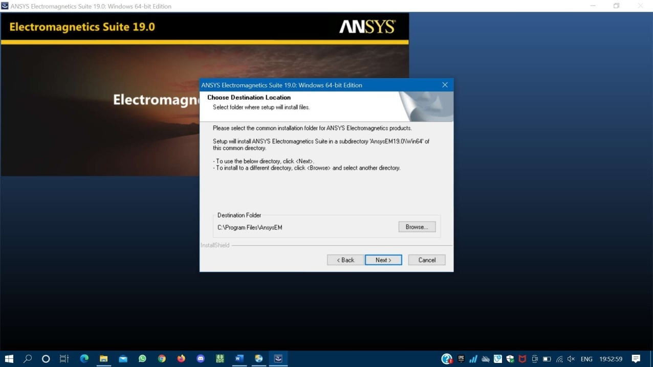

**Fig4.12: Selecting the directive**

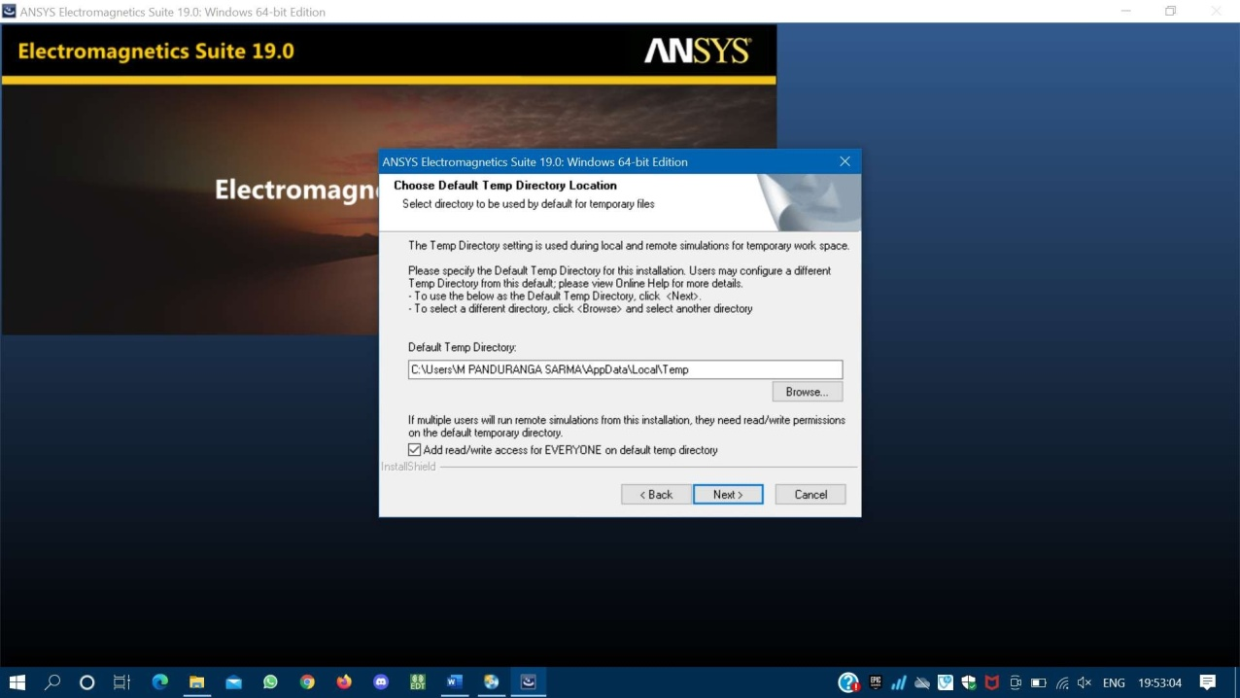

**Fig4.13: Select install directory**

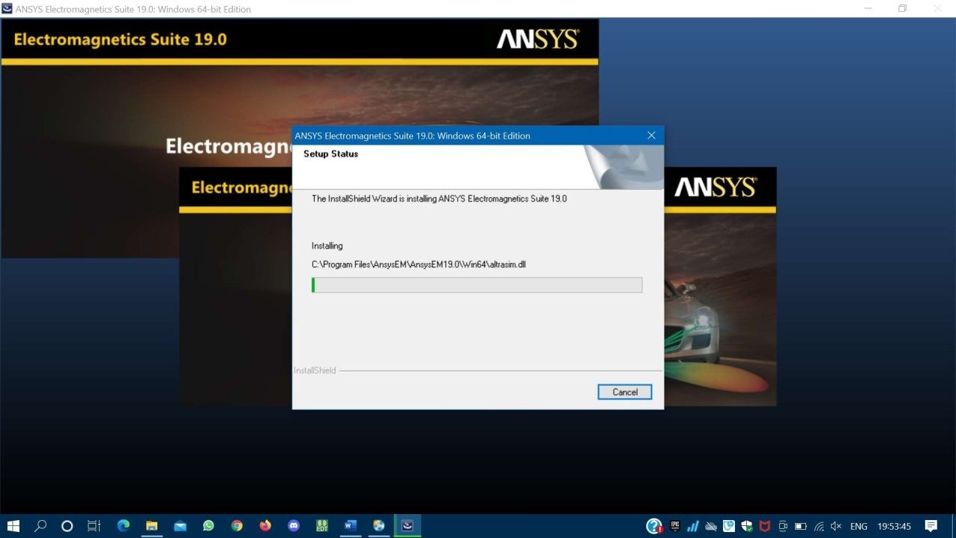

**Fig4.14: Wait till the installation get completed**

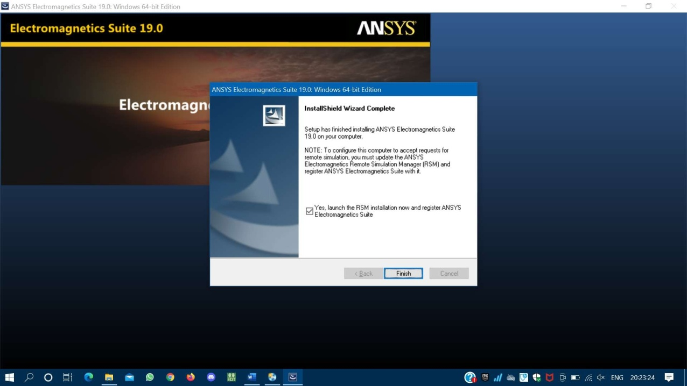

**Fig4.15: Click on “finish” to run the ANSYS**

* + 1. **SIMULATION PROCEDURE**

Step 1: Create a new project Click File>New

A new project is listed in the project tree in the Project Manager window.



Step 2: Inserting an HFSS Design

Click Project>Insert HFSS Design or Insert HFSS-IE Design.

The new design is listed in the project tree. It is named HFSS Design.

The 3D Modeler window appears to the right of the Project Manager. You can now create the model geometry.

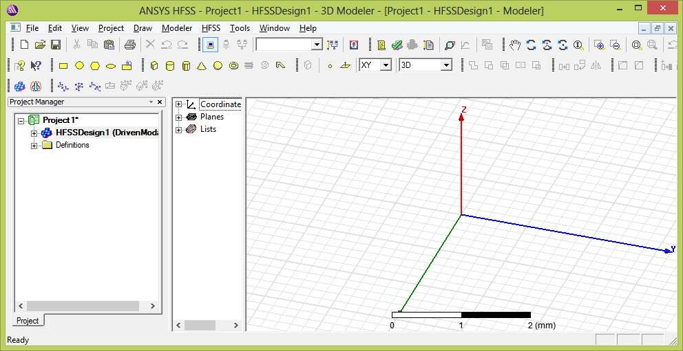

Step 3: Select the solution type

Click HFSS>Solution Type. The Solution Type dialog box appears.

Select one of the following solution types Driven Model

Driven Terminal Eigen mode

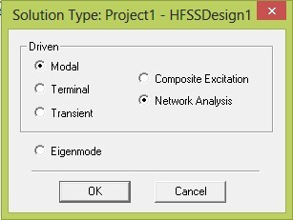

Step 4: Setting Units of Measurement for the Model To set the model’s units of measurement:

Click Modeler>Units. The Set Model Units dialog box appears.

Select the new units for the model from the Select units pull-down list.

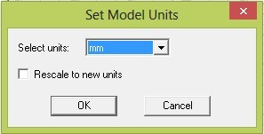

Step 5: Assigning Materials

You can add, remove, and edit materials in two main ways

Using the Tools>Edit Configured Libraries>Materials menu command. Right-clicking Materials in the project tree and selecting Edit All Libraries. To assign a material to an object, follow this general procedure:

Select the object to which you want to assign a material. Click Modeler>Assign Material

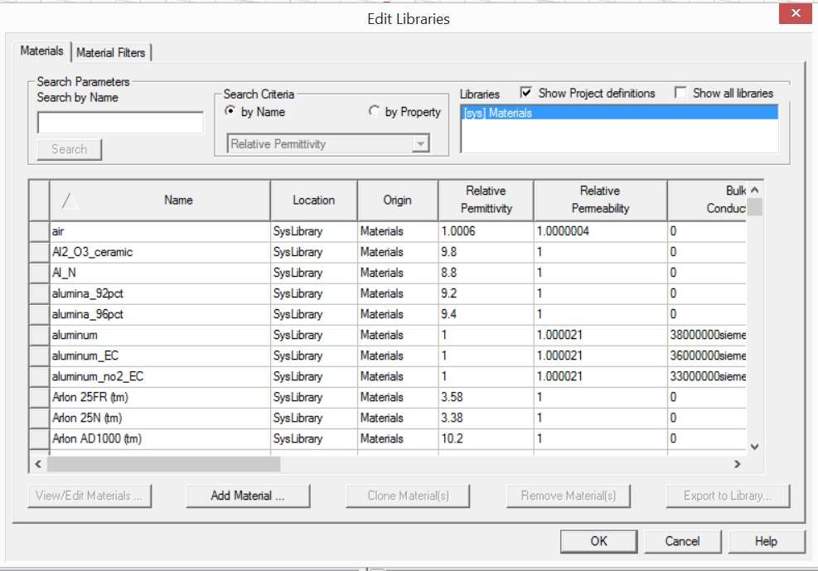

Step 6: Assigning HFSS-IE Boundaries:

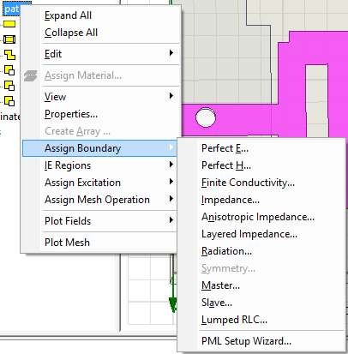

Step 7: Running Simulations

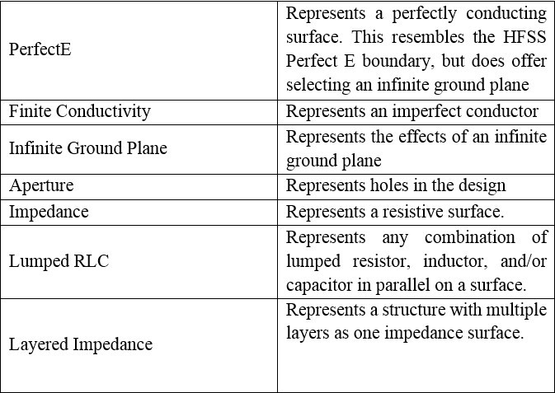

For Analyze command,

Right-click on a setup or sweep in the Project tree, and click the command on the context menu. The Analyze All command applies to all enable setup

To use this command, either click HFSS>Analyze All or right-click on the Analysis icon in the Project tree and select Analyze All from the popup menu.



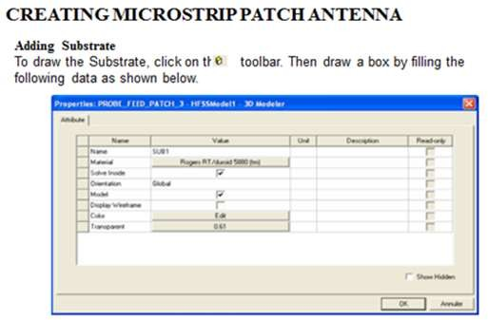

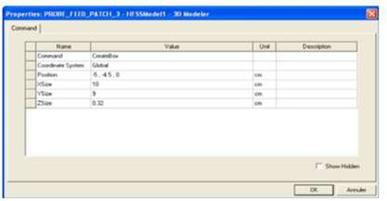

**Adding Frequency Sweep**

* + - 1. To add a frequency sweep, select the menu item HFSS > Analysis Setup > Add Sweep.
      2. Select Solution Setup Setup1. Click OK button. Then Edit Sweep Window.
      3. Sweep Type: Fast
      4. Frequency Setup Type: Linear Count
      5. Start: 3.1 GHz
      6. Stop: 10.6 GHz,
      7. Count: 200. Click OK button.
      8. Model Validation
      9. To validate the model, select the menu HFSS > Validation Check. Click the Close button. To view any errors or warnings messages, use the Message Manager.
      10. Analyze.
      11. To start the solution process, select the menu item HFSS > Analyze.
      12. To create a 2D polar far field plot go to Results > create Report. change the Report Type to Far Field.
      13. Display type to Radiation Pattern.
      14. Click OK.

# Chapter 5 RESULTS DISCUSSION

### SIMULATION RESULT

In this project, pentagon shaped antenna was designed and simulated for four variants of pentagon shaped antenna to notch WLAN (5-6 GHz) band from the UWB spectrum. These four variants include basis pentagonal antenna, design with EBG, design with slot and design with EBG and slot.

##### PENTAGON SHAPED UWB ANTENNA

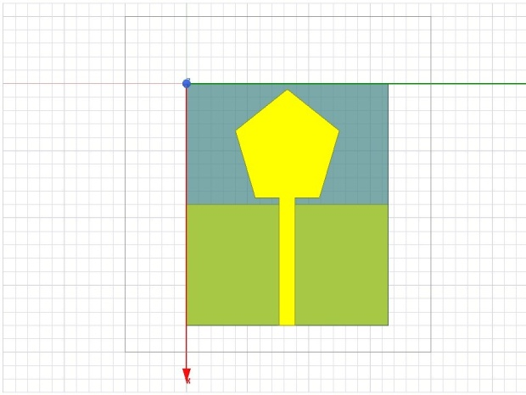

**Fig5.1: Pentagonal UWB antenna**

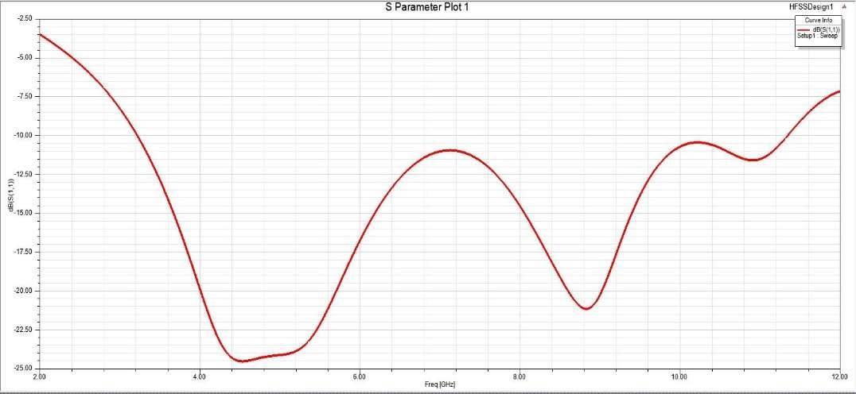

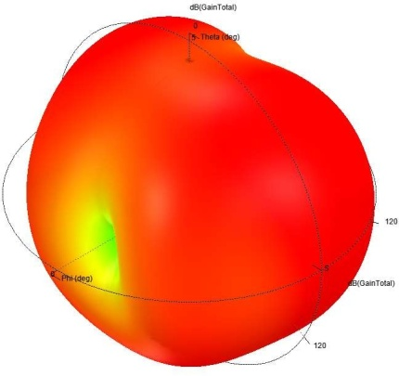**Fig5.2: S parameters of Pentagonal UWB antenna**

**Fig5.13: 3D Radiation Pattern of Pentagonal UWB antenna**

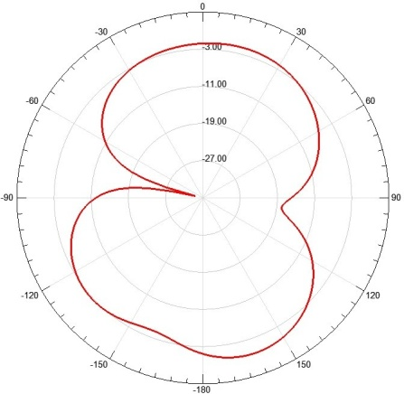

**Fig5.4: H plane Radiation Pattern**

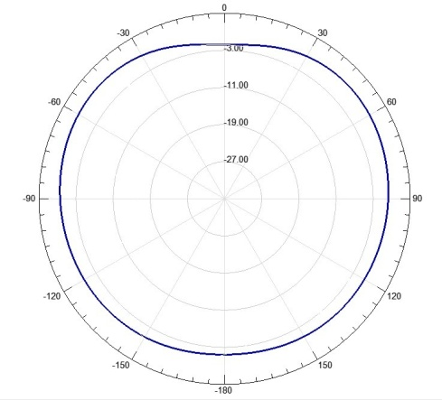

**Fig 5.5: E plane Radiation Pattern**

After simulating the above design for the given dimension, we got return loss (S11) as show in above fig were all the frequency range lie below 10db from 3.1-10.6 GHz.

##### PENTAGON SHAPED ANTENNA WITH EBG

**Fig5.6: Pentagonal UWB antenna with EBG**

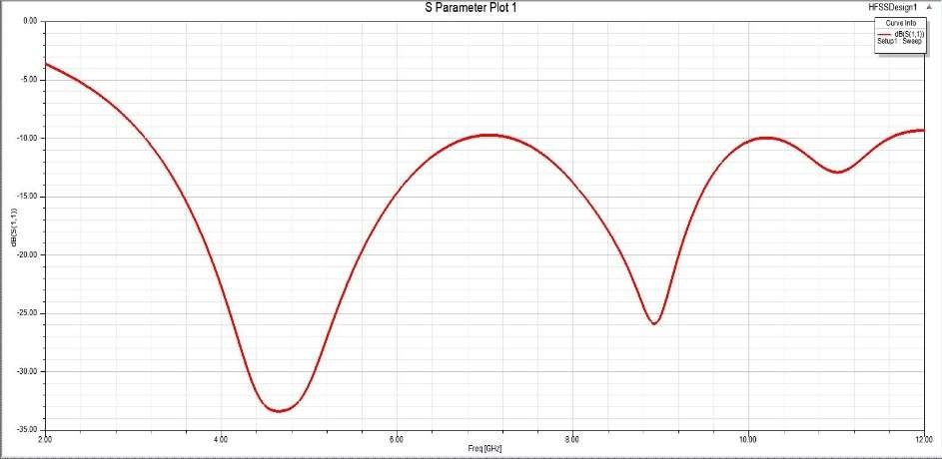

**Fig 5.7: S parameters of Pentagonal UWB antenna with EBG**

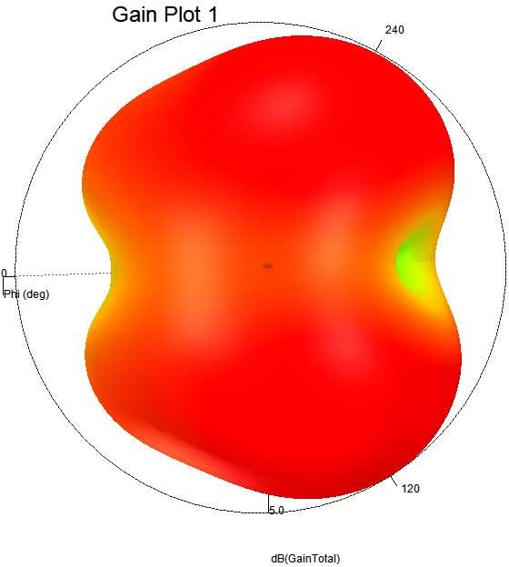

**Fig5.8: 3D Radiation pattern of Pentagonal UWB antenna with EBG**

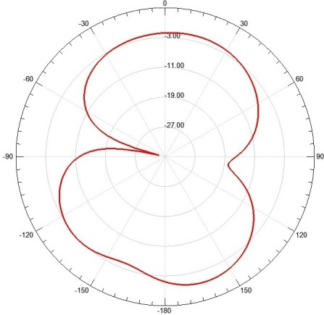

**Fig5.9: H plane Radiation Pattern**

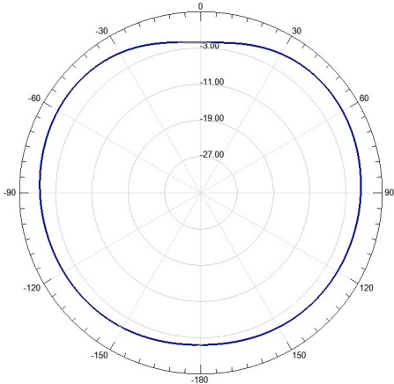

**Fig5.10: E plane Radiation Pattern**

After simulating the above design for the given dimension, we got return loss (S11) as show in above fig were all the frequency range lie below 10db from 3.1-10.6.

##### PENTAGON SHAPED ANTENNA WITH RECTANGULAR SLOT

**Fig5.11: Pentagonal UWB antenna with rectangular slot**

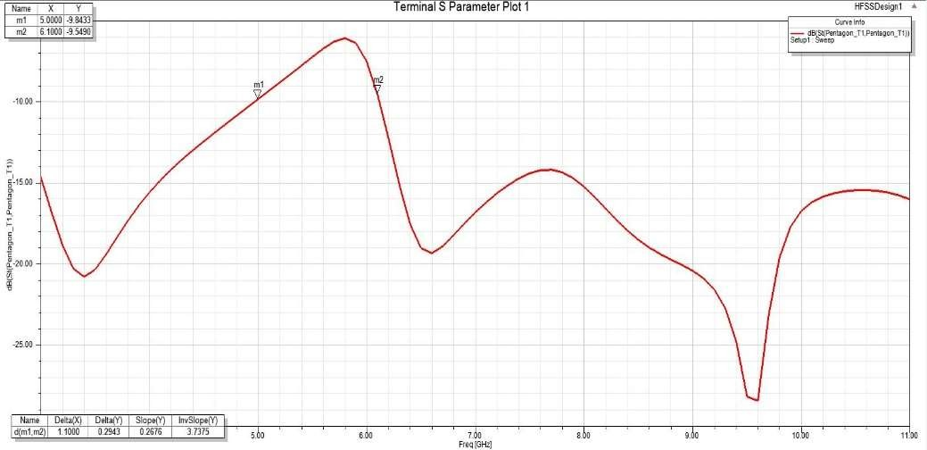

**Fig5.12: S parameters of Pentagonal UWB antenna with rectangular slot**

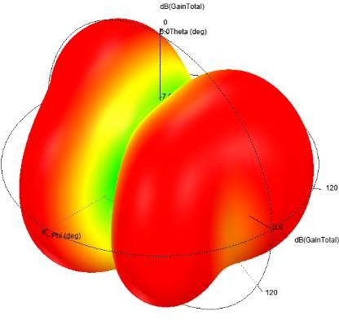

**Fig 5.13: Radiation pattern of Pentagonal UWB antenna with rectangular slot**

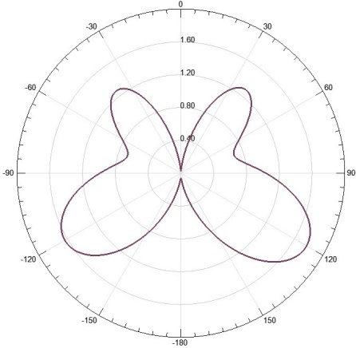

**Fig5.14: H plane Radiation Pattern**

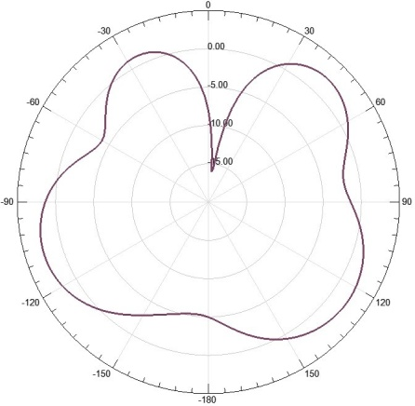

**Fig5.15: E plane Radiation Pattern**

S parameter for the pentagon shaped antenna with rectangular slot is give above where we can see that frequency range from 5-6Ghz is greater then -10db, WLAN band is been eliminated by using rectangular slot.

##### PENTAGON SHAPED ANTENNA WITH RECTANGULAR SLOT AND EBG

**Fig5.16: Pentagonal UWB antenna with slot and EBG**

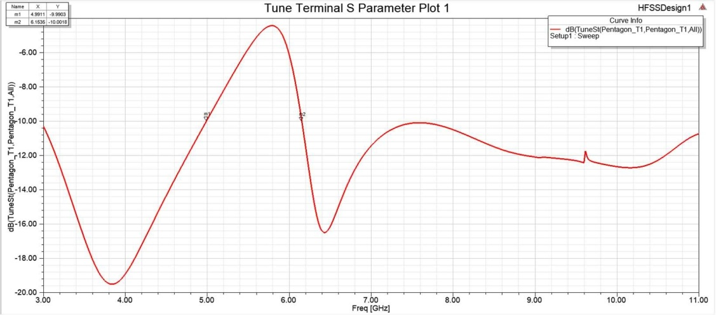

**Fig5.17: S parameters of Pentagonal UWB antenna with slot and EBG**

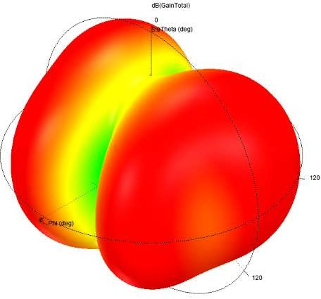

**Fig5.18: 3D Radiation pattern of Pentagonal UWB antenna with slot and EBG**

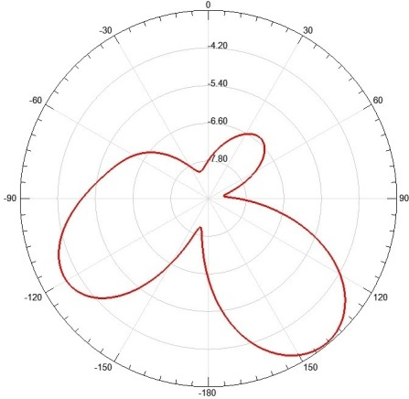

**Fig5.19: H plane Radiation Pattern**



**Fig5.20: E plane Radiation Pattern**

S-parameter for the above antenna design is shown in the above Fig were frequency range from 5-6Ghz yields greater than -10db i.e., we are able to eliminate: WLAN by adding EBG and the rectangular slot.

##### OUTPUT COMPARISON TABLE

|  |  |
| --- | --- |
| Antenna Name | Gain |
| Pentagon UWB Antenna | 2.14 |
| Pentagon UWB Antenna With EBG | 2.78 |
| Pentagon UWB Antenna With slot Without EBG | 2.42 |
| Pentagon UWB Antenna With slot and EBG | 2.9 |

**Chapter 6 CONCLUSION AND FUTURE SCOPE**

* 1. **CONCLUSION**

A UWB pentagonal shape antenna is proposed, which yields BW from 3.1 GHz to more than

10.6 GHz. Further by altering UWB antenna design, tuneable notch responses are obtained by using modified rectangular slot and hexagon-shaped EBG structures in 5.16-6.08 GHz frequency band. The surface current distributions at the notched frequency with and without modified rectangular shaped slot is also computed and investigated. The slot dimension increases the input impedance of TM21 mode and decreases the resonance frequency which results in notch characteristics. The experimentally measured results have shown a satisfactory agreement with the simulated ones. The developed antenna provides good radiation patterns over UWB range except in the notched band.

### FUTURE SCOPE

The technique of using EBG and slot in design of a Pentagon UWB antenna can be extended to implement triple band notching for application specific microstrip patch antennas.

Antenna parameters such as Ground plane length, length and width of slot/EBG can be modified to achieve return loss of Notched Bandwidths greater than -5 db.

### REFERENCES

1. . First Report and Order, “Revision of part 15 of the commission’s rules regarding ultra- wideband transmission systems,” Federal Communications Commission, FCC 02-48, 2002.
2. Kumar G. and K. P. Ray, Broadband Microstrip Antenna, Artech House, USA, 2003.
3. Garg, B. P., I. Bahl, and A. Ittipiboon, Microstrip Antenna Design Handbook, Artech House, USA, 2001.
4. Ray, K. P., “Design aspects of printed monopole antennas for ultra-wide band applications,” Int. J. Antennas Propag., Vol. 2008, 1–8, 2008.
5. Agrawall, N. P., G. Kumar, and K. P. Ray, “Wide-band planar monopole antennas,” IEEE Trans. Antennas Propag., Vol. 46, No. 2, 294–295, 1998.
6. Wong, K. L. and Y. F. Lin, “Stripline-fed printed triangular monopole,” Electron. Lett., Vol. 33, No. 17, 1428–1429, 1997.
7. Jose, J. V., A. S. Rekh, and M. J. Jose, “Double-elliptical shaped miniaturized micro strip patch antenna for ultra-wide band applications,” Progress In Electromagnetics Research C, Vol. 97, 95– 107, 2019.
8. Ray, K. P., S. S. Thakur, and R. A. Deshmukh, “UWB printed sectoral monopole antenna with dual polarization,” Microw. Opt. Technol. Lett., Vol. 54, No. 9, 2066–2070, 2012.
9. Thomas, P., D. D. Krishna, M. Gopikrishna, U. G. Kalappura, and C. K. Aanandan, “Compact planar ultra-wideband bevelled monopole for portable UWB systems,” Electron. Lett., Vol. 47, No. 20, 1112–1114, 2011.
10. Mewara, H. S., J. K. Deegwal, and M. M. Sharma, “A slot resonators based quintuple band-notched Y-shaped planar monopole ultra-wideband antenna,” AEU — Int. J. Electron. Commun., Vol. 83, 470–478, 2018.
11. Zhu, Y., F.-S. Zhang, C. Lin, Q. Zhang, and J.-X. Huang, “A novel dual band-notched monopole antenna for ultra-wideband application,” Progress In Electromagnetics Research Letters, Vol. 16, 109–117, 2010.
12. Deshmukh, A. A. and P. V. Mohadikar, “Modified rectangular shape patch antennas for ultra-wide band and notch characteristics response,” Microw. Opt. Technol. Lett., Vol. 59, No. 7, 1524–1529, 2017.
13. Guichi, F., M. Challal, and T. A. Denidni, “A novel dual band-notch ultra-wideband monopole antenna using parasitic stubs and slot,” Microw. Opt. Technol. Lett., Vol. 60, No. 7, 1737–1744, 2018.
14. Haraz Ahmed, O. M. and A. R. Sebak, “Numerical and experimental investigation of a novel ultrawideband butterfly shaped printed monopole antenna with bandstop function,” Progress In Electromagnetics Research C, Vol. 18, 111–121, 2011.
15. Abbosh, A. M., “Design of a CPW-fed band-notched UWB antenna using a feeder- embedded slotline resonator,” Int. J. Antennas Propag., Vol. 2008, 1–5, 2008.176 Kadam and Deshmukh
16. Wang, C., Z.-H. Yan, B. Li, and P. Xu, “A dual band-notched UWB printed antenna with C-shaped and U-shaped slots,” Microw. Opt. Technol. Lett., Vol. 54, No. 6, 1450–1452, 2012.
17. Mishra, S. K. and J. Mukherjee, “Compact printed dual band-notched U-shape UWB antenna,” Progress In Electromagnetics Research C, Vol. 27, 169–181, 2012.
18. Yadav, A., S. Agrawal, and R. P. Yadav, “SRR and S-shape slot loaded triple band notched UWB antenna,” AEU — Int. J. Electron. Commun., Vol. 79, 192–198, 2017.
19. Lv, Y., J. Zhang, and H. Hou, “A novel triple band-notched UWB printed monopole antenna,” Progress In Electromagnetics Research M, Vol. 81, 85–95, 2019.
20. Jaglan, N., B. K. Kanaujia, S. D. Gupta, and S. Srivastava, “Triple band notched UWB antenna design using electromagnetic band gap structures,” Progress In Electromagnetics Research C, Vol. 66, 139–147, 2016.
21. Mandal, T. and S. Das, “Design of dual notch band UWB printed monopole antenna using electromagnetic-bandgap structure,” Microw. Opt. Technol. Lett., Vol. 56, No. 9, 2195–2199, 2014.
22. Choukiker, Y. K. and S. K. Behera, “Modified Sierpinski square fractal antenna covering ultra-wide band application with band notch characteristics,” IET Microwaves, Antennas Propag., Vol. 8, No. 7, 506–512, 2014.
23. Ghahremani, M., C. Ghobadi, J. Nourinia, M. S. Ellis, F. Alizadeh, and B. Mohammadi, “Miniaturised UWB antenna with dual-band rejection of WLAN/WiMAX using slitted EBG structure,” IET Microwaves, Antennas Propag., Vol. 13, No. 3, 360–366, 2019.
24. Tsai, L. C., “A ultrawideband antenna with dual-band band-notch filters,” Microw. Opt. Technol. Lett., Vol. 59, No. 8, 1861–1866, 2017.
25. Mansouri, Z., F. B. Zarrabi, and A. Saee Arezoomand, “Multi notch-band CPW-fed circular-disk UWB antenna using underground filter,” Int. J. Electron. Lett., Vol. 6, No. 2, 204–213, 2018.
26. Denidni, T. A. and Z. Weng, “Hybrid ultrawideband dielectric resonator antenna and band-notched designs,” IET Microwaves, Antennas Propag., Vol. 5, No. 4, 450–458, 2011.
27. Zhu, F., et al., “Dual band-notched tapered slot antenna using λ/4 band-stop filters,” IET Microwaves, Antennas Propag., Vol. 6, No. 15, 1665–1673, 2012.
28. Fertas, K., F. Ghanem, A. Azrar, and R. Aksas, “UWB antenna with sweeping dual notch based on metamaterial SRR fictive rotation,” Microw. Opt. Technol. Lett., Vol. 62, No. 2, 956–963, 2020.
29. Zhang, J., T. Chen, L. Hua, and W. Wang, “A compact differential-fed UWB antenna with bandnotched characteristics,” Progress In Electromagnetics Research M, Vol. 83, 171–179, 2019.
30. Yang, F. and Y. Rahmat-Samii, “Microstrip antennas integrated with electromagnetic band-gap (EBG) structures: A low mutual coupling design for array applications,” IEEE Trans. Antennas Propag., Vol. 51, No. 10 II, 2936–2946, 2003.
31. Deshmukh, A. A., P. Mohadikar, and S. Pawar, “Formulation of resonant length for regular and modified shapes printed monopole antennas,” Int. J. Microw. Opt. Technol., Vol. 13, No. 6, 478– 486, 2018